President, Parents Association
Site Coordinator for Natural History Main (NHM)
Jane Paul is mom to Henry (Cinnamon Bear) and William (Penguin), who have been at SEEC since they were infants. She worked at the Smithsonian American Art Museum until 2013 managing traveling exhibitions and government loans. The Pauls live in DC and spend their free time playing baseball and enjoying nature around their home. Jane is also on SEEC’s Board of Directors, term 2013-2016.
Email: jane.paul@ymail.com Phone: 202-316-4256
Vice President, Parents Association
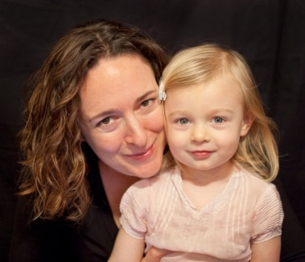 | Karen Osborn is a 2 year SEEC parent and has been with the Smithsonian for 3 years. Her daughter Bella started as a Wallaby and graduated as a Cinnamon Bear last year. Her son Ronin started as a Duckling and is now a Dragonfly. Karen is new to the SEEC Board this year. She served as PA Site Coordinator for NHM and NHE sites last year. She is a deep-sea invertebrate biologist and curator of worms and crustaceans in the Department of Invertebrate Zoology at the Natural History Museum. The Osborn's live in Annandale, Virginia where they like to bike, hike, play outdoors, and make art.  Email: osbornk@si.edu Phone: 202-633-3668
Site Coordinator for American History (AH)
Mitch Toda has been a part of the SEEC family since his daughter Chloe started as a Toucan in 2008 and this is his last year at SEEC with Ethan as a Honey Bear. Originally from Northern California, Mitch and his wife Sharon moved out to Virginia in 2005 to work at the Smithsonian. Mitch has been at the SI Archives for 9 years and works to appraise, preserve, and make accessible the records that document the history of the Smithsonian, including its museums and research centers. Having recently completed an addition to their home in Falls Church, their time is engaged in figuring out what to do with the new space as well as landscaping the yard. Besides that they thoroughly enjoy cooking, baking, farmer's markets, trying new restaurants, camping, and spending time at the beach.
Email: TodaM@si.edu

Site Coordinator for Natural History East (NHE)
 | Jen McCarter is mother to Eleanor Remy (Dragonfly), who just started her second year at SEEC. Jen works at the Smithsonian Science Education Center where she coordinates professional development programs for K-8 science teachers. The McCarter Madrids have lived in and around DC for the past six years, and just recently relocated to Hyattsville, MD. These native Californians love traveling, cooking, visiting museums, and enjoying the great outdoors. When they’re not playing soccer they can be found supporting Liverpool FC. Go Reds! Email: Mccarterj@si.edu
Cottontail Class Coordinator (infants)
 | Christina Talcott is the mother of Hollis (Holly) Dater, a Cottontail, and works in the Smithsonian's Office of Special Events and Protocol, where she edits briefings and invitations, manages various calendars, and samples leftovers from events. Christina, her husband Jay Dater, and Holly live in Silver Spring, and their current favorite activities include cooking (Holly supervises), visiting with family and friends, and challenging Holl to parent vs. baby dance-offs. Email: Christina.Talcott@gmail.com
Duckling Class Coordinator (infants)
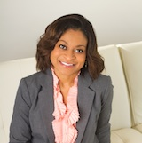 | Malena Brookshire is mom to Michael (Duckling), who began his first year with the SEEC in 2014! Malena works at the Securities and Exchange Commission managing various aspects of the agency’s budget and Strategic Plan. Her family enjoys traveling, hiking local and national parks, and spending time at nearby rivers and beaches.  Email: malena.brookshire@gmail.com
Toucan Class Coordinator (toddlers)
 | Joanna Marsh is the mother of Rose Cynamon, a Toucan, who started at SEEC in 2013. She is the curator of contemporary art at the Smithsonian American Art Museum, where she has worked since 2007. Joanna, her husband (Alex), and Rose live in Northwest Washington near Meridian Hill Park. The family loves taking long walks together and discovering new parks for Rose to explore. Email: marshj@si.edu

Dragonfly Class Coordinator (toddlers)
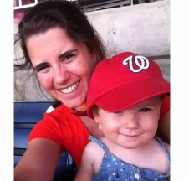 | Kate Earnest is mom to Emily (Dragonfly) who is in her second year at SEEC. She works in development at the Smithsonian American Art Museum. The Earnests live on Capitol Hill and enjoy exploring their neighborhood parks and all that their city has to offer.  Email: ErnestK@si.edu
Penguin Class Coordinator (twos)
 | Effie Kapsalis is mother to Melina (Penguin). She is head of digital & outreach at the Smithsonian Institution Archives and has been at the Smithsonian for nearing 10 years! Effie, Andrew (husband), and Melina live on the Hill near H street and enjoy trips to the Arboretum, camping, climbing, yoga, good food, and hikes with their pup, Hazel. Email: KapsalisE@si.edu
Firefly Class Coordinator (twos)
 | Jean Belitsky is mother to Logan (firefly) who has been at SEEC since he was an infant. Jean works at the Smithsonian Hirshhorn Museum and Sculpture Garden in the Development office. Jean, Eugene and Logan like to spend time outdoors and enjoy swimming, biking, playing T-ball and taking nature walks. Email: BelitskyJ@si.edu
Wallaby Class Coordinator (threes)
 | Penne Kirkpatrick is mother to Ellen (Wallaby) and Adam (Cottontail). The Kirkpatricks have been part of the SEEC family since 2012. Penne has been with the Smithsonian 9 years in various roles. Currently, she coordinates donor events and programming as a member of the Campaign Team in the Office of Advancement. The Kirkpatricks live in Arlington. Email: KirkpatrickP@si.edu
Koala Class Coordinator (threes)
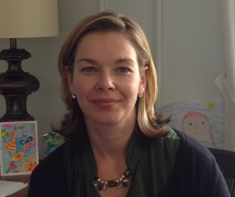 | Evie Hasch is mom to Koalas Hudson & Willow and second-grader Sophia, a SEEC Alum. Evie is Deputy for Policy at the National Telecommunications and Information Administration, U.S. Department of Commerce, where she advises the White House on Internet and cyberspace policy. Her husband Dennis is Branch Manager of Web Services at the National Museum of National History. They spend their weekends playing soccer, swimming, hiking, kayaking, and enjoying bonfires under the well-loved trees of their backyard. Email: erhasch@gmail.com
Honey Bear Class Co-Coordinators (fours)
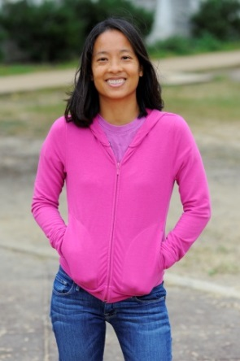 | Michelle Uejio celebrated her thirty seventh birthday on September 19. This means that she is a year older than her husband, but it also means that she is a Virgo. As her sign would suggest, Michelle is meticulous, reliable, and modest. Michelle enjoys taking advantage of her Capital Bikeshare membership for her morning commute, and playing on the monkey bars after dinner. Having recently returned to the National Capital Region, Michelle looks forward to picking apples at Hartland Orchards, and visiting a waste water treatment plant. She looks forward to working with Angie to make this year a great one for the Honey Bears. Email: muejio@oig.si.edu
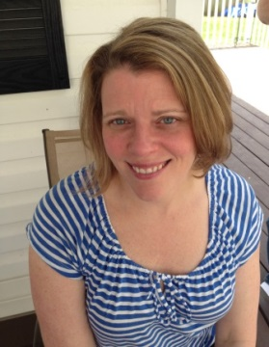 | Angie Saffoe is the mother of Carl (Honey Bear) who has been at SEEC since he was four months old. Angie is an attorney who works in the Office of General Counsel at the Financial Industry Regulatory Authority. Angie is married to Craig, who is the curator for Great Cats, Andean Bears, and the Kids' Farm at the National Zoo. The Saffoe family lives in Springfield and enjoys spending time in their yard, visiting family, going to amusement parks, and doing anything Thomas-related. Email: amp1974@gmail.com
Cinnamon Bear Class Coordinator (fours)
 | Michelle Atkins is mother to Gregory (Cinnamon Bear) and Matthew (Firefly). She is going on 18 years of working at the Smithsonian American Art Museum, raising private funds for the museum’s initiatives. The Atkins family resides in Upper Marlboro, Maryland and enjoys sports, movies, museums, and spending time outdoors. Email: atkinsm@si.edu
Kindergarten Class Coordinator
Carolyn Greene McKee is mom to Ailsa (Kindergarten) and Freya (Wallaby), both of whom started at SEEC as Fireflies. She is an Associate General Counsel at the National Gallery of Art and loves running into SEEC classes in NGA galleries. She and her husband, Carlton, their girls, and their goldendoodle live in the Del Ray neighborhood of Alexandria, VA. Starting this year, Carolyn also is serving as a parent representative on SEEC's Board of Trustees.
Email: carolyn.mckee@gmail.com

