What Will I See at the Smithsonian Natural History Museum?

I will be visiting Mammals Hall soon. It is at the Smithsonian Natural History Museum. What will I see?

I may see many of the mammals that are in the video at this YouTube address: http://www.youtube.com/watch?v=htGiUWhxyhQ. The video helps children and adults see Mammals Hall from their home or classroom, before their visit.

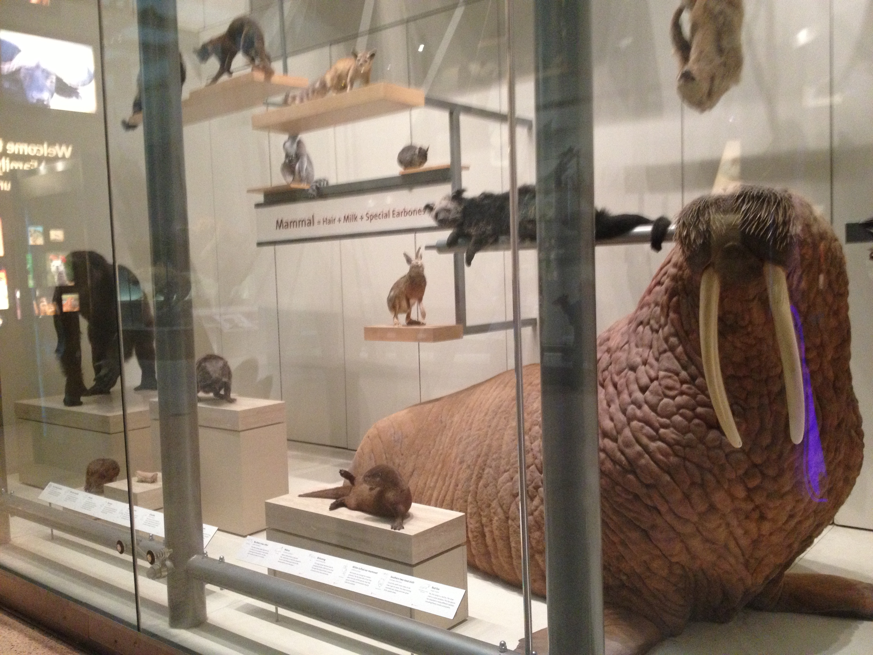

Just like in the video, there are big mammals, and small ones.

Just like in the video, there are mammals I have seen before, others that maybe I have not seen before.

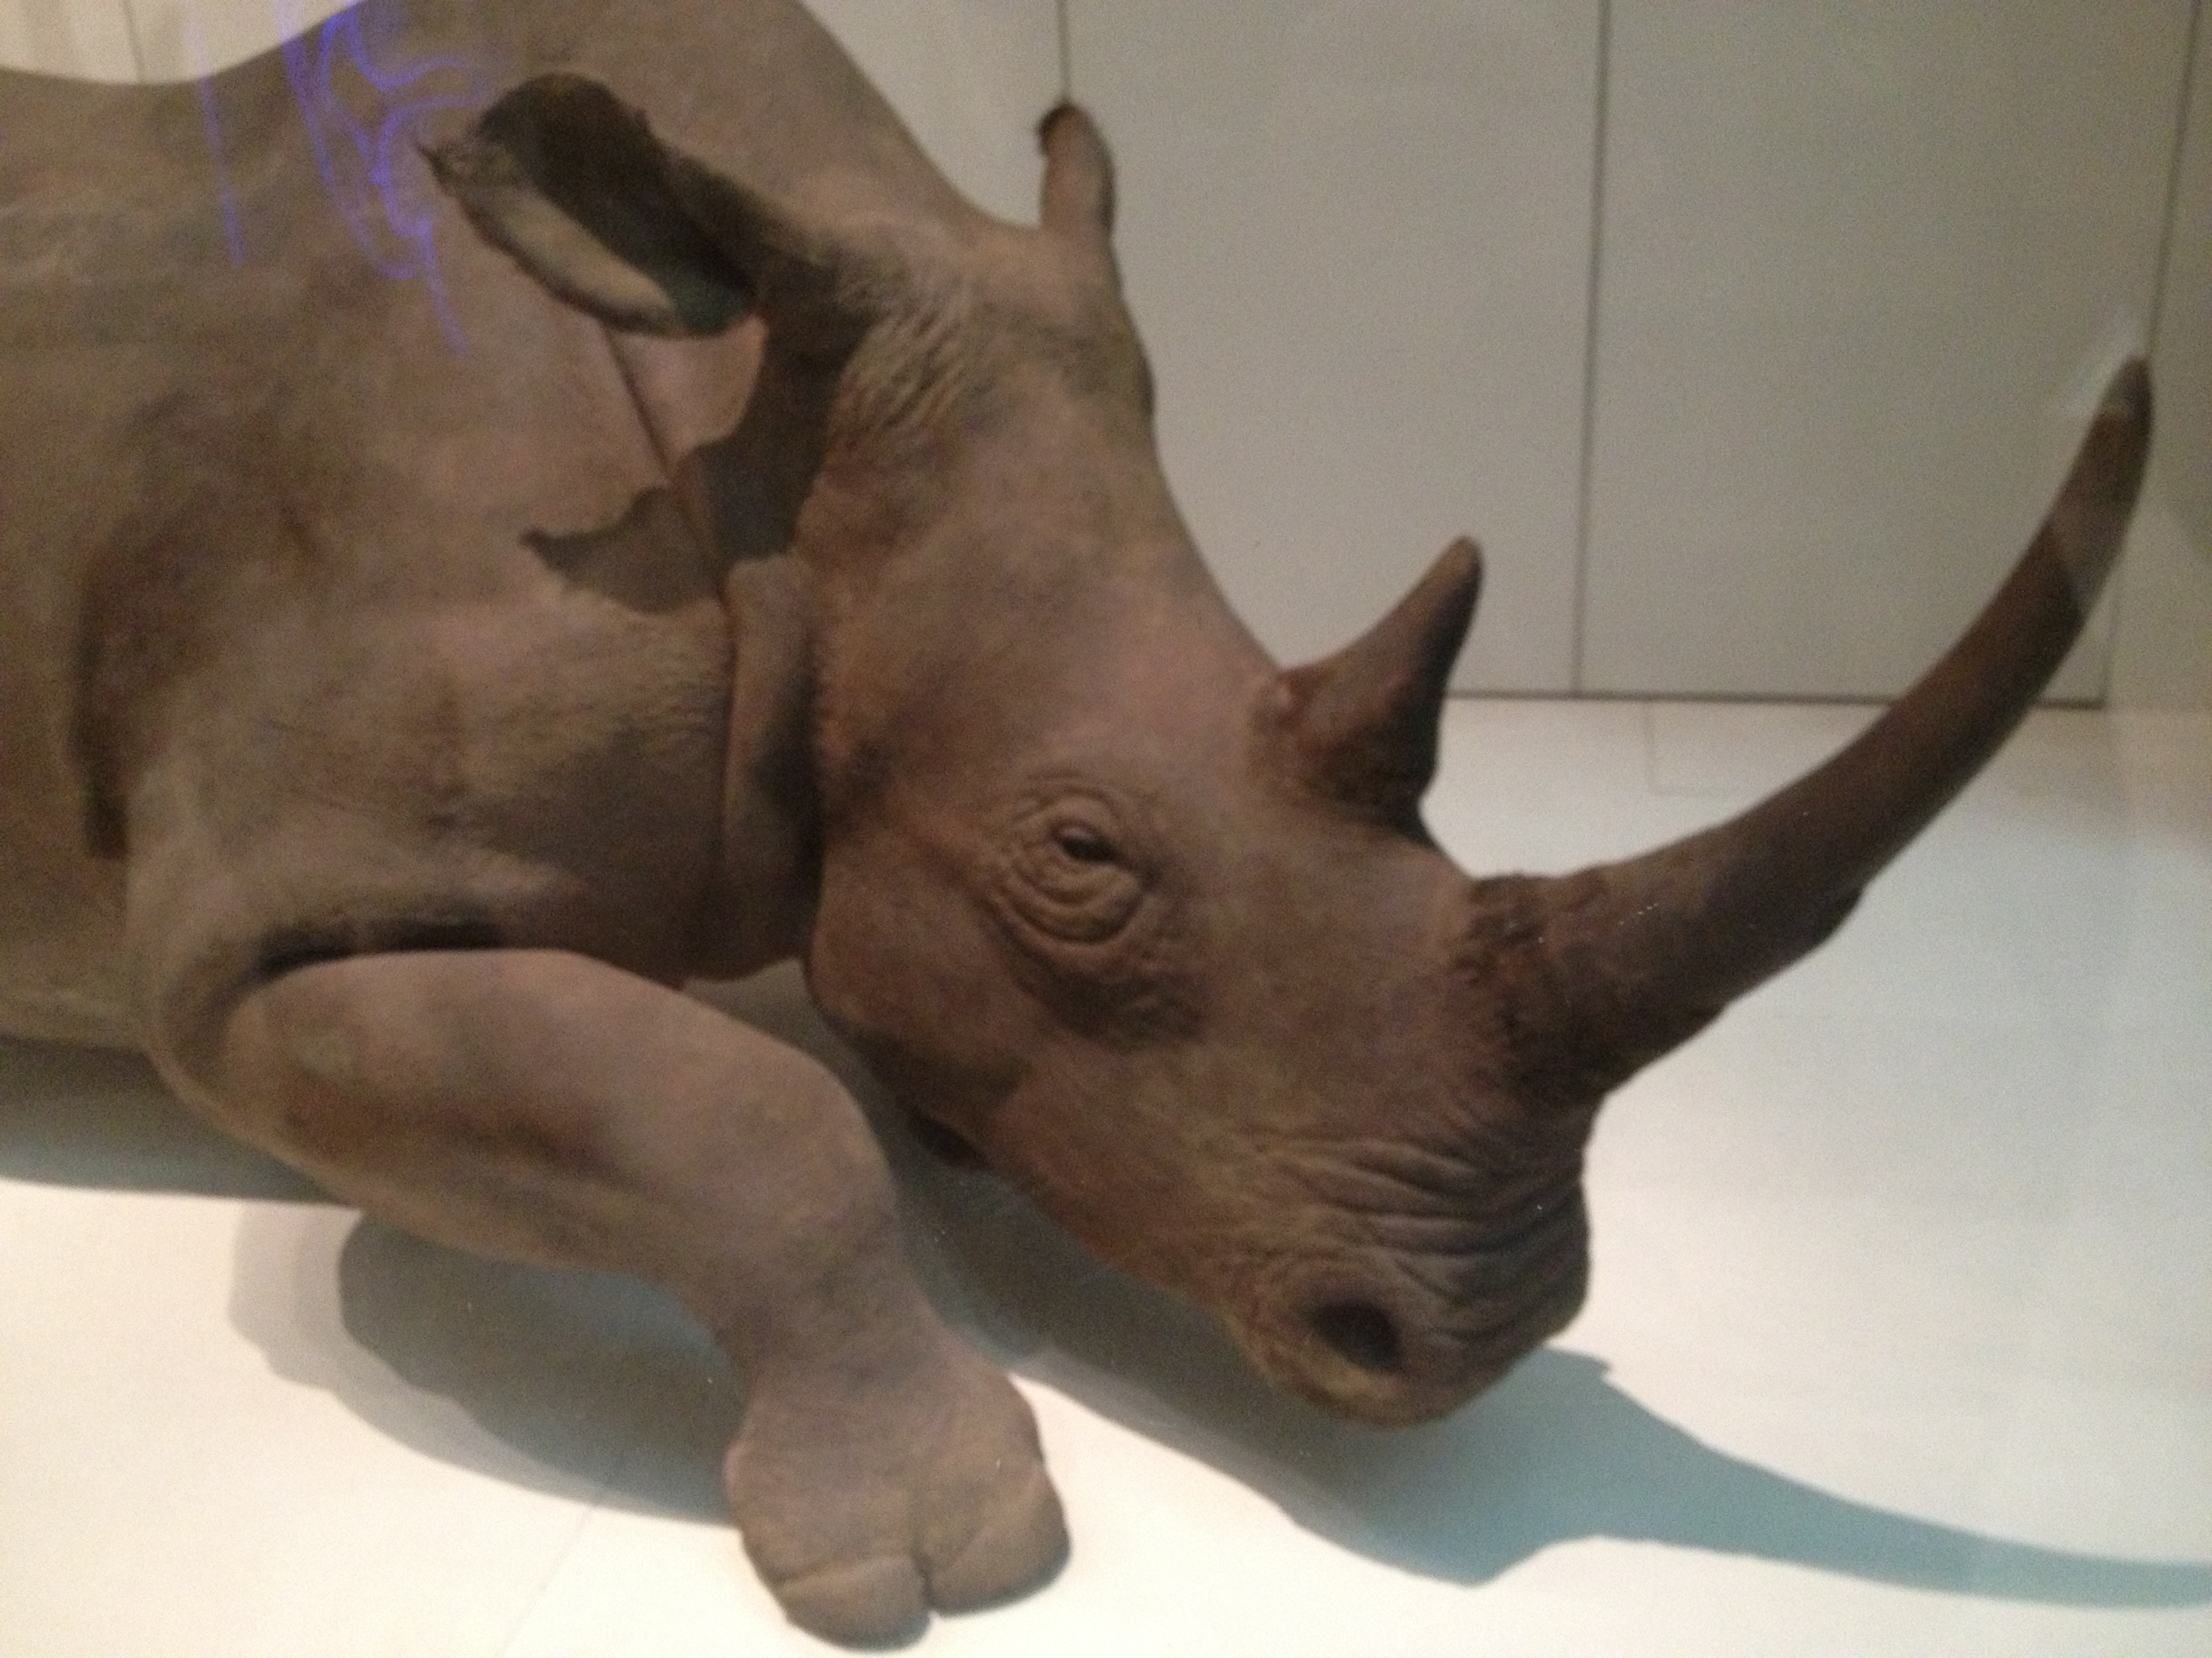

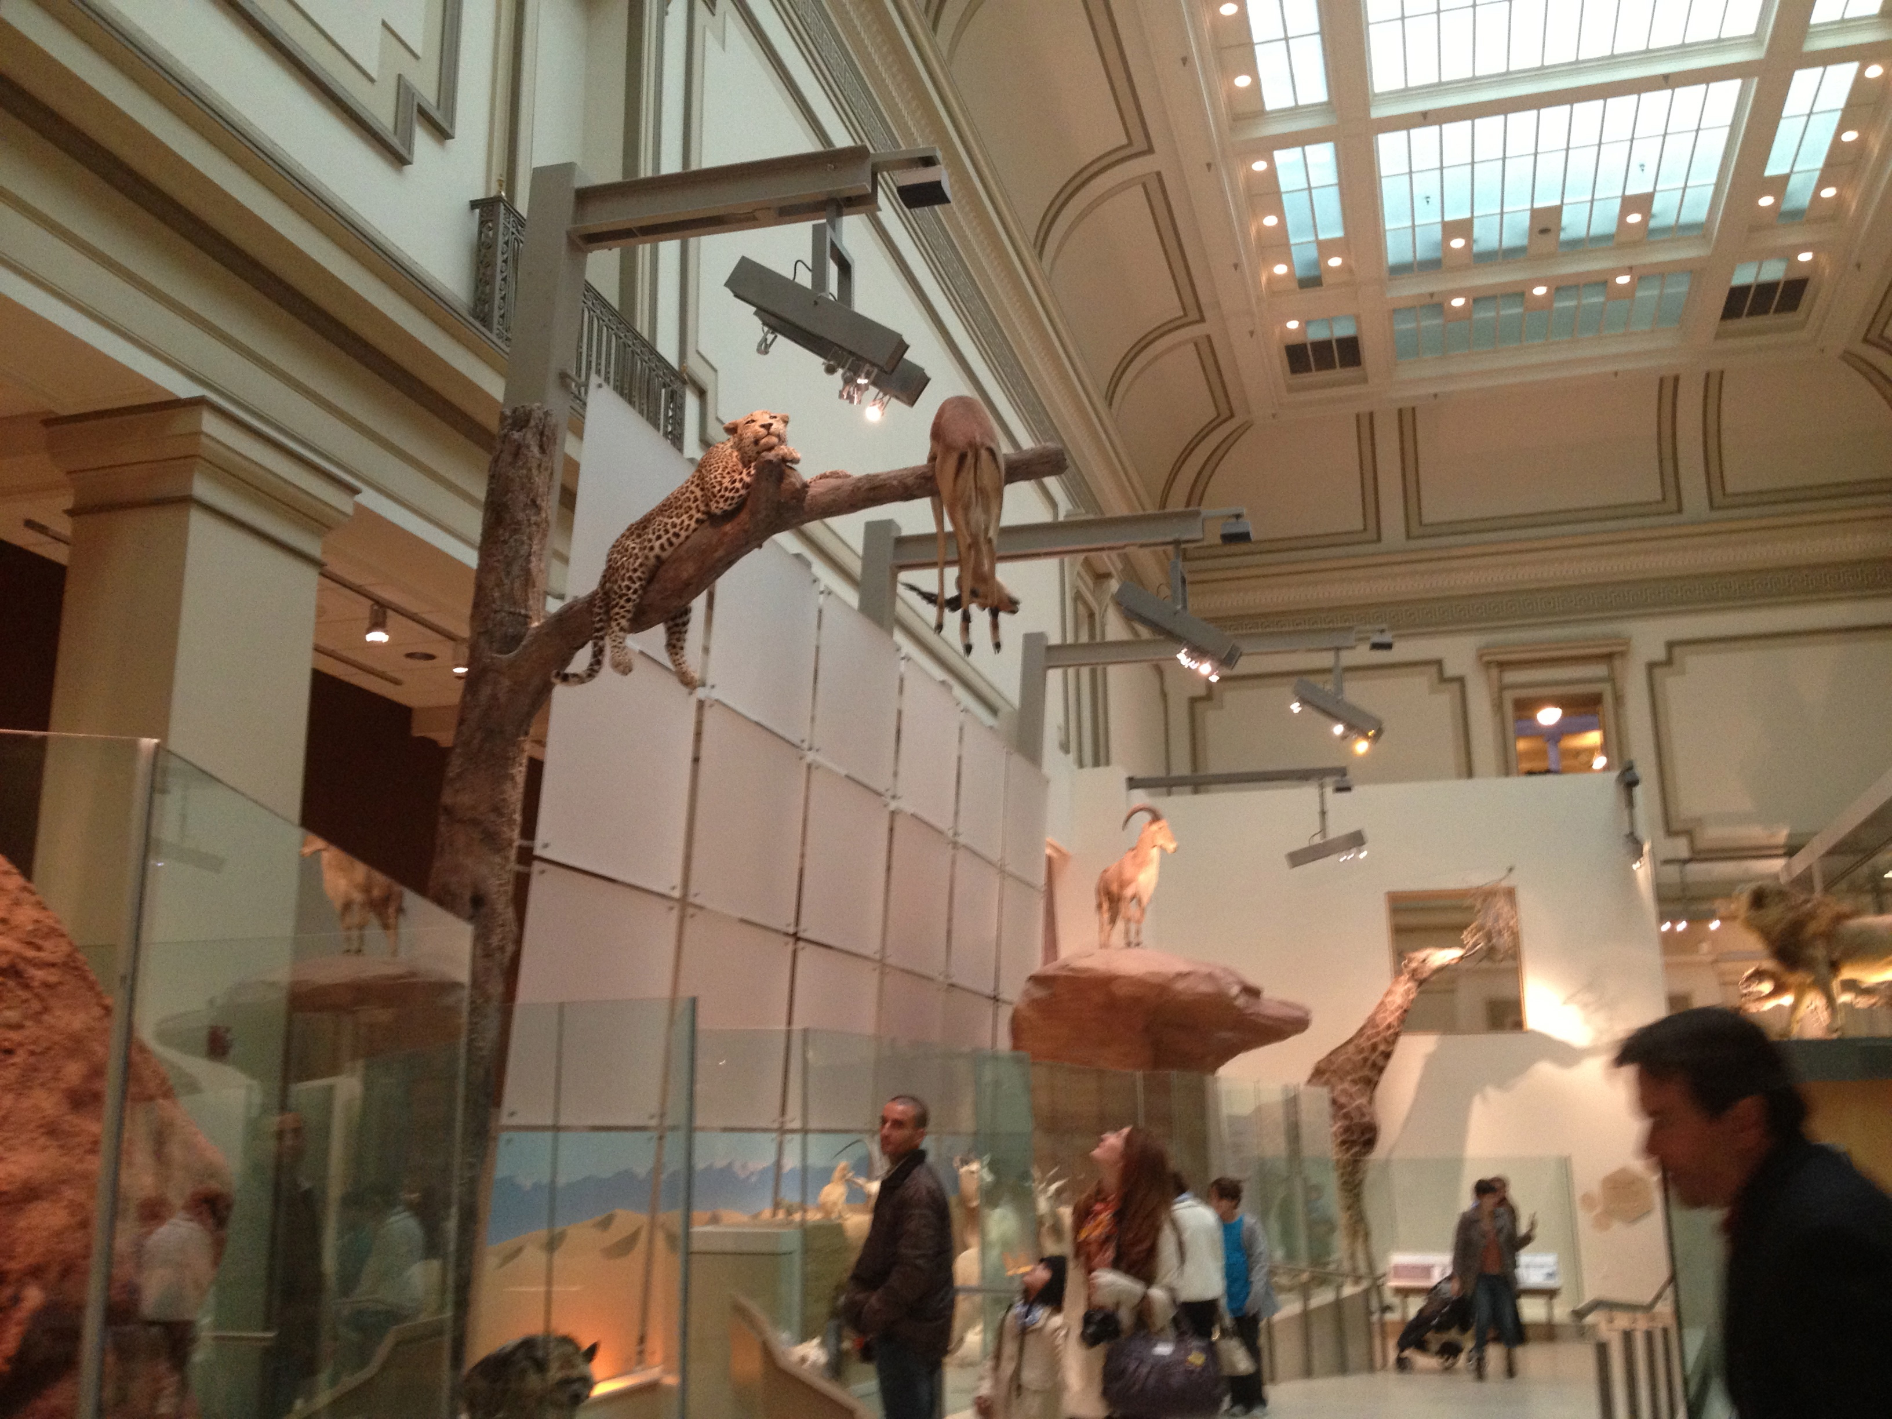

Just like in the video, there are mammals up high, and mammals that are low.

The person who made the video about Mammals Hall looked high and low. Many times, he focused his camera on one mammal at a time. That’s often the best way to visit a large exhibit at the Smithsonian: Looking high, looking low, and looking at things one at a time.

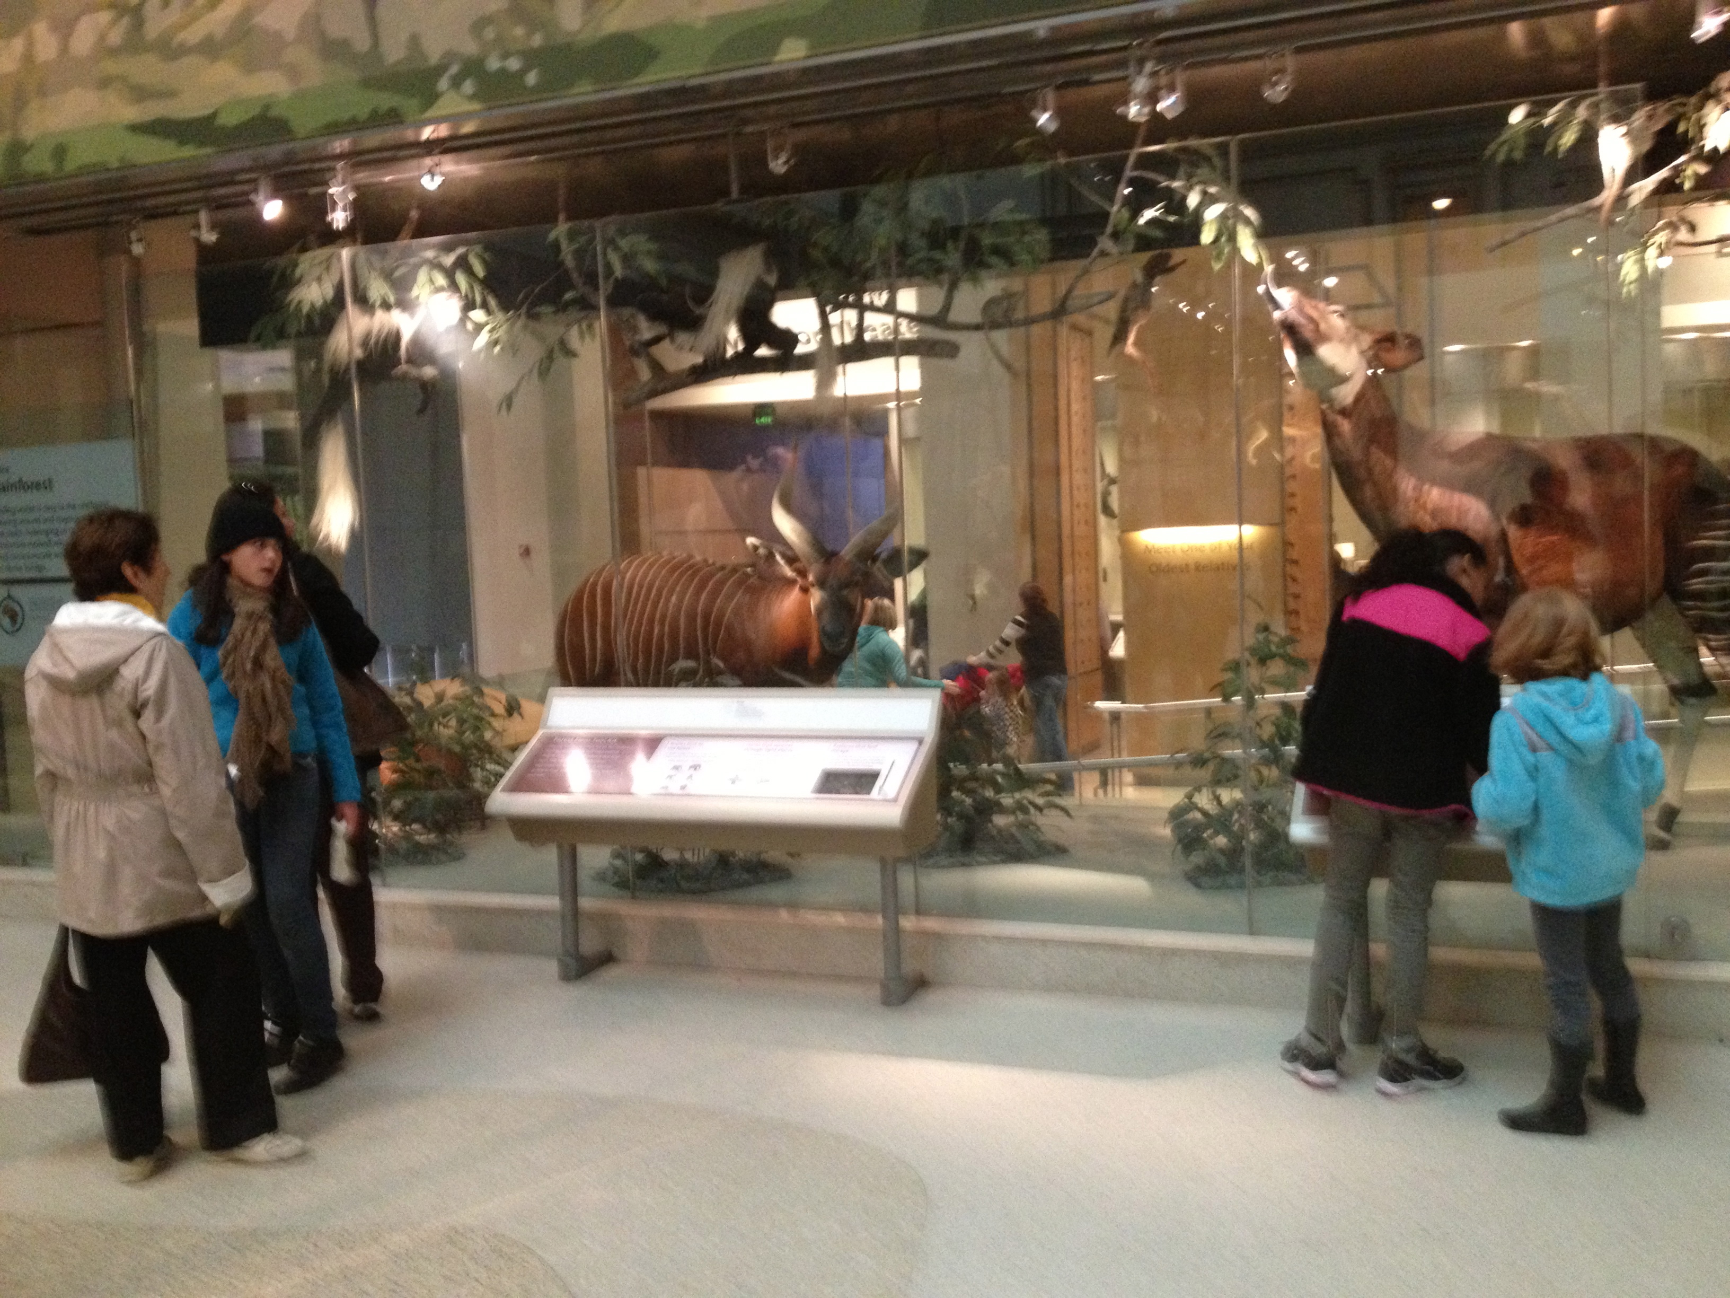

When I visit Mammals Hall, I will try to look high and low, and learn about the mammals one at a time.

