Understanding My Adult in a Big Place

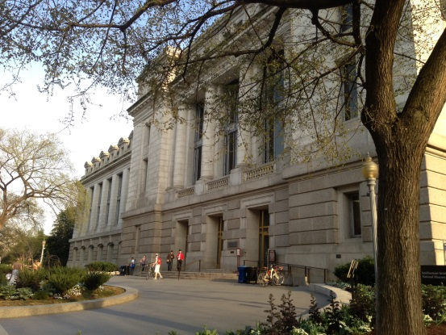
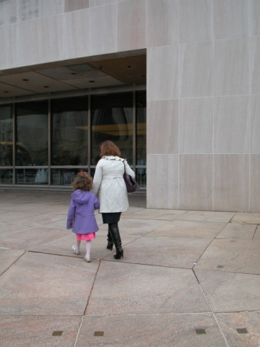
Sometimes I visit big places, like a museum. There are often many people in a big place. It’s important for me to visit big places with an adult. Understanding why an adult is with me may make it easier to visit big places.

My adult is older than me. S/he has visited many big places before.

My adult knows how to visit a big place. My adult has learned what to do in a place with a lot of people.
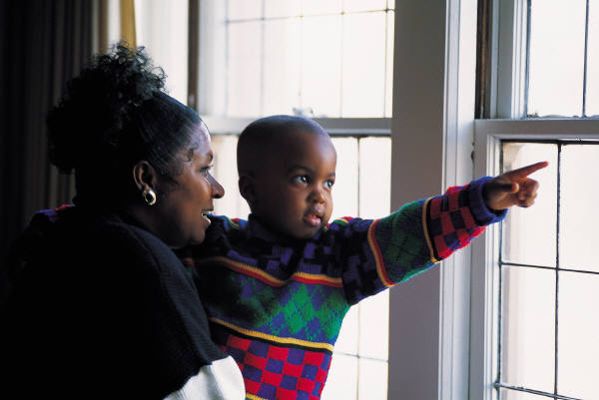
My adult cares about my safety. Staying safe is a big part of having fun. To be sure that I have a fun day, my adult works to keep my day safe.

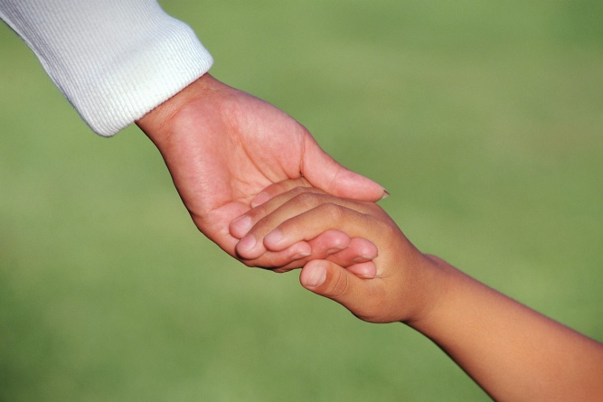
My adult wants me to feel comfortable and have fun, too. Adults can be very helpful if there’s a problem, they usually know what to do.

Sometimes I visit big places, like a museum. Having my adult with me helps me to have a safe, fun, and comfortable visit!

Insert picture of you and
your adult!

Museum Security Rules and Routines

Every museum has rules and routines. Many people visit a museum. It’s important to keep everyone safe.
Museum rules and routines help people
1. know what to expect, and
2. what to do.

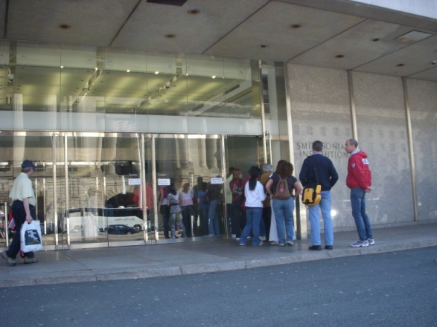
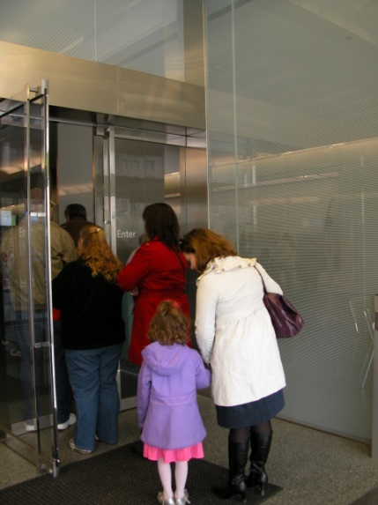
The Smithsonian Institution’s National Museum of Natural History has more than one front door. Having extra doors helps many people enter a museum easily.

If there are many people, a line forms. This is okay. Each person will have a turn to go into the museum.

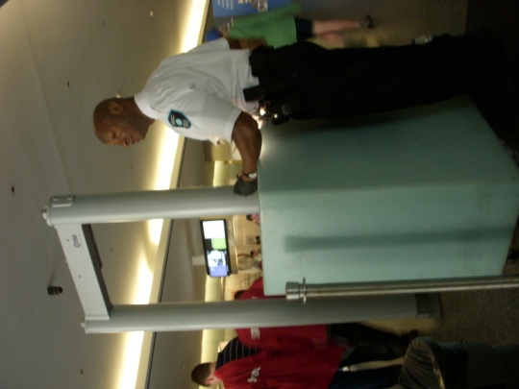
There is a security officer at each door. This is to keep people safe.

Security officers check all bags, handbags, and backpacks. They are looking for items that could be a problem in a museum.

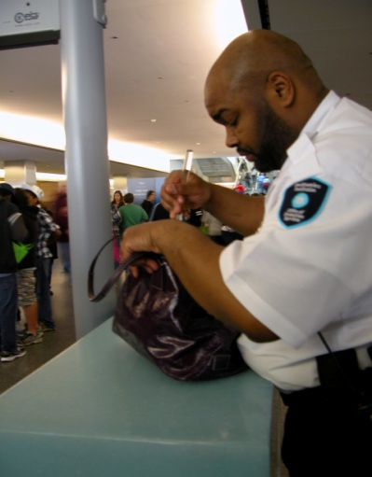
The museum has a security routine. Visitors:
- Open their bags.
- Give them to the security officer.
- Walk through the scanner.
- Wait patiently to get their bags back.

The security officer lets each person know when it is ok to enter the museum.

When I go to the museum there will be a security officer at the door. If I have a backpack or a bag, It is important that I:

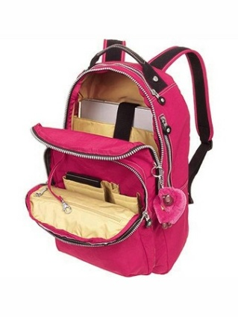
- Open my bag or backpack.
- Give it to the security officer.
- Walk through the scanner.
- Wait to get it back.

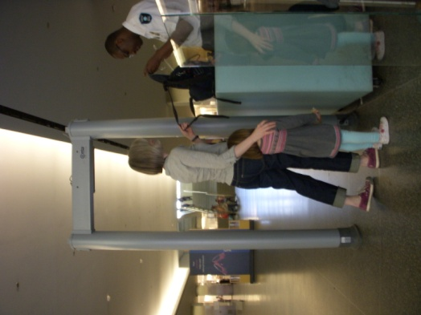
Then, the security officer will tell me when my adult and I may go into the museum.

Getting into the museum is a very important routine. There may be a line of people. A security officer will check each bag. Knowing what to expect helps me know what to do.

