What is a Mounted Animal?

Soon I will visit the Hall of Mammals at the Smithsonian Natural History Museum. I will see many mounted animals.
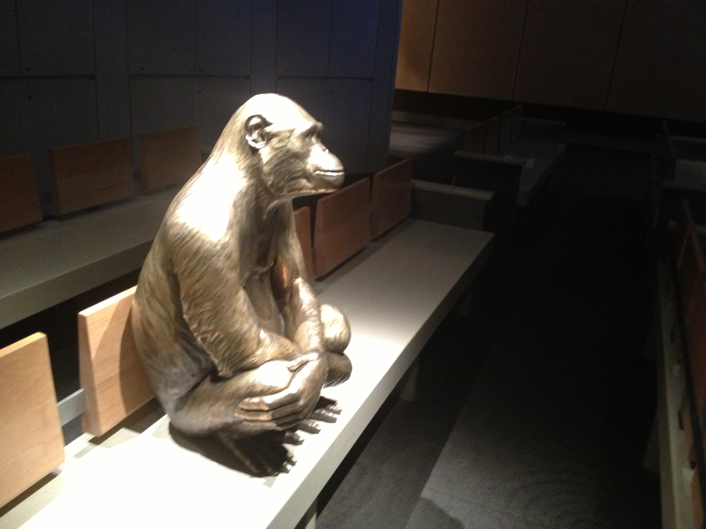
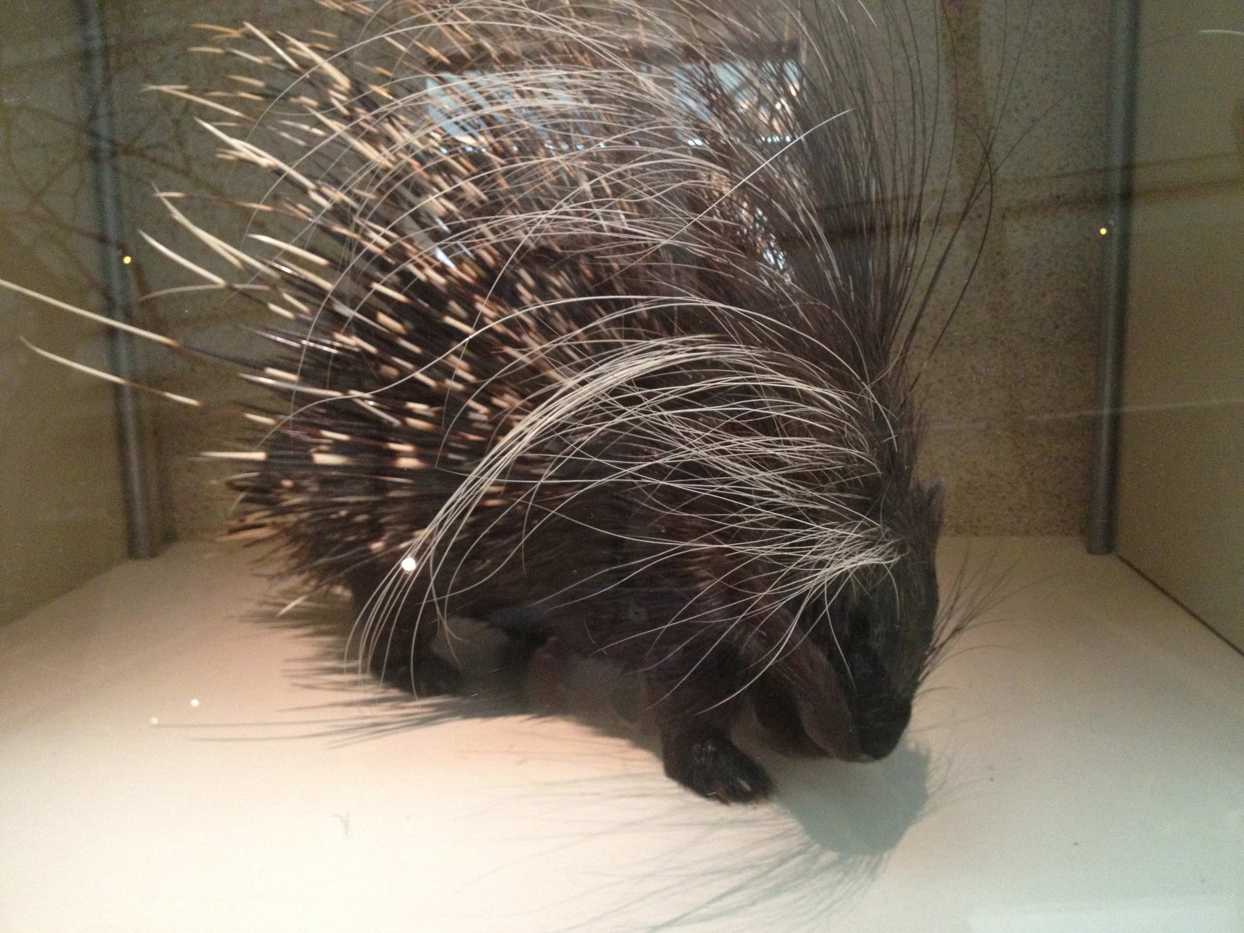

On the left is a mounted porcupine. A taxidermist made it by stretching a porcupine skin over a form of wood and wire. Mounted mammals are not alive. They do not eat, breathe, sleep, or grow. Still, they look very real. Mounted animals are used as trophies and for research and study. In the Museum of Natural History, mounted animals help people learn about mammals, fish, and other animals, too.

Above and right is a statue of a monkey. This statue is placed on a bench in the museum theatre. It looks like the statue is watching a video about himself (photo of video at right)! Many people think
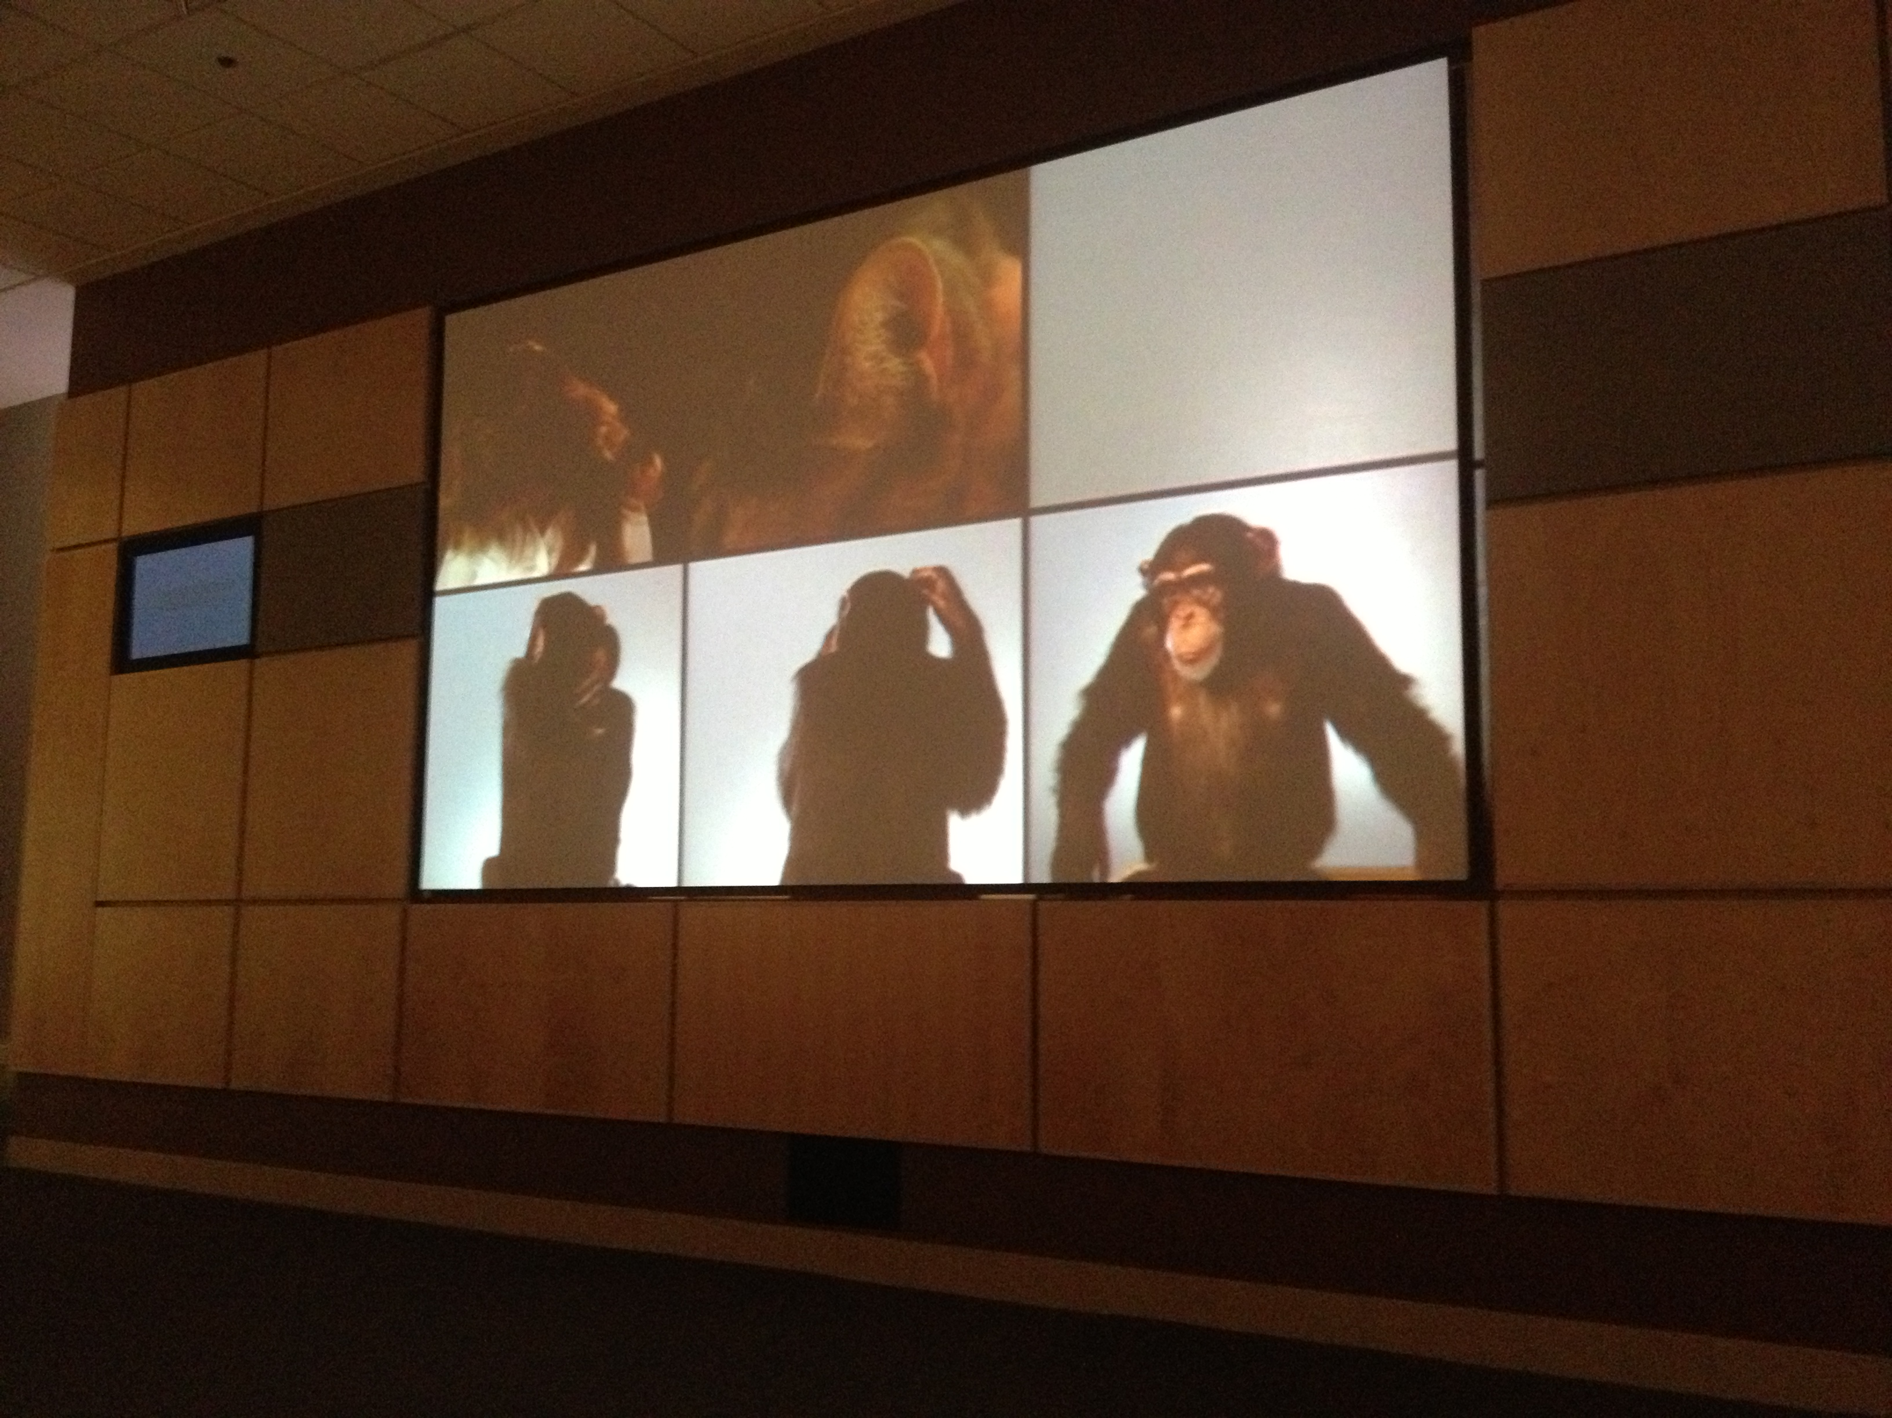

that statues like this one are interesting and fun. It is not a mounted animal, though. It is not made of fur, wood and wire. It is made of metal.

When I visit Mammals Hall, I will see many kinds of mounted animals. Even though they cannot eat, breathe, sleep, or grow, they can help me learn about animals around the world.

