SMITHSONIAN EARLY ENRICHMENT CENTER
SEEC PARENT MANUAL [REVISED AUGUST 2013]

PHILOSOPHY, GOALS AND CURRICULUM OF THE SCHOOL

Introduction

The Smithsonian Early Enrichment Center is a museum-based Lab school with centers located in the National Museum of American History and the National Museum of Natural History. The first center, licensed for fifty (50) pre-kindergarten children, was opened in 1988 in the National Museum of American History. In January of 1991, a second center for infants and toddlers, ages three months through two years, opened in the Arts and Industries Building. In the summer of 1998, the third center opened to add more classrooms for toddlers and two-year-olds as well as SEEC's first kindergarten classroom. When the Arts & Industries Building closed in 2004-2005, SEEC’s infant/toddler program moved to a modular building on the east side of American History. In December of 2012 the infant/toddler program moved to its current facility adjacent to the original site in Natural History.

SEEC offers a year-round educational program for young children, two months through six years of age. All sites open at 7:30 am and close at 6:00 pm on weekdays
All classes begin promptly at 9:00 each morning and time across the day is devoted to both structured and unstructured educational activities. Activities for all children include classroom experiences as well as museum visits, which take the children outside of the center around the National Mall and into the community. Parents arriving after 9:00 am are responsible for finding their child's class if they are not in their classrooms as many of the classes head out for their visits between 9-10am. Our programs provide diverse opportunities that focus on cognitive, social and language development, utilizing the rich community resources that exist around Washington.

The Smithsonian Early Enrichment Center has as its highest priority the provision of outstanding educational care in a nurturing environment. The program fosters the total social, emotional, aesthetic, intellectual, and physical growth of the child by using the unique resources of the Institution and surrounding community to challenge children. Children are offered educational experiences tailored to their individual developmental levels and SEEC welcomes children with special needs. Each classroom is led by a team of professionally trained teachers who provide new challenges, while encouraging each child to grow at his or her own pace. The program encourages children to search for knowledge, think, reason, question, solve problems, and experiment; all while fostering a positive self-concept.

Parents are strongly encouraged to be involved with SEEC as partners in the education and development of their children. Parents may participate in establishing policy as members of the Board of Directors or by providing support of the school through various volunteer program opportunities within the Parents Association. Parent suggestions and questions about curriculum are always welcome and can be brought to the Executive Director at any time.
Curriculum Overview

SEEC uses an “emergent curriculum” model in each of our classrooms. This means that each classroom may be pursuing a different topic as dictated by the interests of the children. Learning research shows that children are more fully engaged when they are interested and invested in the topic being taught and an emergent curriculum takes full advantage of this work. In addition, a classroom may pursue a topic for as little as a week or as long as six or more weeks, depending on the interest level of the children and the possibility for extending and expanding the ideas.

In 1987 the Smithsonian received a generous grant from the Clark-Winchcole Foundation to develop "Museum Magic", a model museum-based curriculum with special emphasis on multicultural education. The curriculum, developed specifically for SEEC, is designed to take advantage of the invaluable resources of the Smithsonian. SEEC children are introduced to the museums to provide them with exposure to a variety of objects and experiences. This use of multiple exposures over time has been shown to improve flexibility of thought and transfer of knowledge, concepts we are proposing to study across the school in the coming year. Museum Magic serves as a resource for all of the teachers as they plan their daily activities as the themes found in the curriculum are ones which often emerge from the children’s interests.

The SEEC curriculum is all-inclusive in that it focuses on how children learn, rather than simply presenting information to be learned. The focus on higher level thinking skills, often referred to as 21st Century skills, is considered to be an important educational goal. The curriculum honors individual, cultural and developmental differences. It is designed to encourage a combination of deep exploration, direct instruction, and independent student exploration; as well as to provide both stimulating and quiet moments. It allows for the expression of ideas and feelings and has as a major goal the enhancement of each child's confidence and self expression.

The curriculum accomplishes these goals by fostering auditory, visual, language, motor, and tactile skills, each of which is presented as one of many ways to process information. The museum's resources are valuable tools with which to teach these skills, while at the same time making learning fun and exciting. For example, when the curriculum focuses on clothing from different cultures the children may visit several nearby museums to see real-life examples, try on clothing that reflects the exhibit, and listen to culturally diverse stories with related illustrations. A different exploration may encourage deep looking at buildings and architecture. A typical daily schedule shows the integration of the museum visit with other early childhood curriculum activities.

The program for infants and toddlers is holistic in nature, with a focus on language and social development. Physical development is also a primary focus as they practice each new skill. Children are learning about the immediate world around them; they are beginning to understand the relationship between themselves and others as well as the relationship between themselves and the world around them. Even as infants, many of the children are ready to reach out into a larger universe. At this point in time, we slowly introduce the children to broader experiences through the museums. The early years are the most vital for building strong neural connections and for providing the child with a variety of experiences that will develop trust and a love of learning. In many ways, the experiences that take place in the infant, toddler and twos classrooms will serve as the basis for learning for the remainder of their lives.

Leaving the Classroom

Regular trips out of the classroom are integral to the SEEC curriculum. Children learn about their world through frequent excursions beyond the classroom into the Smithsonian Institution, as well as into the greater community. It is understood that all children will participate in these trips and that parents will not be asked to sign permission slips if the trip is within walking distance. Parents will be kept informed of field trips off the mall through weekly lesson plans and calendars. Parents will receive advanced notice of field trip details and will be required to return signed permission slips if transportation is necessary. When METRO train, bus, and/or Smithsonian vans are used for transportation, SEEC increases its child/adult ratios to 2:1 for all children except Kindergarten where a 4:1 ratio is used. On the rare occasions that SI vans are used, parents will need to provide appropriate safety seats for the trip.

Parents are invited to participate in most museum visits but may be specifically asked to serve as chaperones when additional adult supervision is necessary. Participation in these activities is part of the volunteer program provided by parents.
EXAMPLE OF A TYPICAL DAILY SCHEDULE

7:30-9:00 Greet Children & Parents; Individual Choice Activities

9:00-9:30 Small Group Activities; Bathroom Time

9:30-11:300 Morning Meetings- Introduce Museum Activity, Stories, Exploration of Objects

Hand washing & Snack

Museum/Community Visit

Playground Activities & Free Play

11:30-12:00 Group Activity for Transition to Lunch - Read Stories & Hand washing

12:00-12:30 Lunch Time & Bathroom

12:30-1:00 Quiet Time for Transition to Naptime (Read stories quietly, listen to tapes)

1:00-2:30 Naptime

2:30-4:30 Afternoon Projects & Small Group Activities

Hand washing & Afternoon Snack

Playground Time

4:30-6:00 Independent Choices - Books, Blocks, Puzzles, Games, Art

6:00 SEEC Closes
TEACHING & LEARNING AT SEEC

What we believe about children
- We believe each child is born a unique individual and we honor that individuality.
- We believe that, from birth, children are brave, energetic, creative, hopeful and capable.
- We believe children are open and curious explorers, capable of deep reflection.
- We honor children’s questions and ideas, believing that they are capable of pursuing and representing knowledge in multiple ways.
- We believe children need to be engaged intellectually, physically and emotionally to maximize their learning.
- We believe children need repeated experiences over time to deepen their understanding of the world.
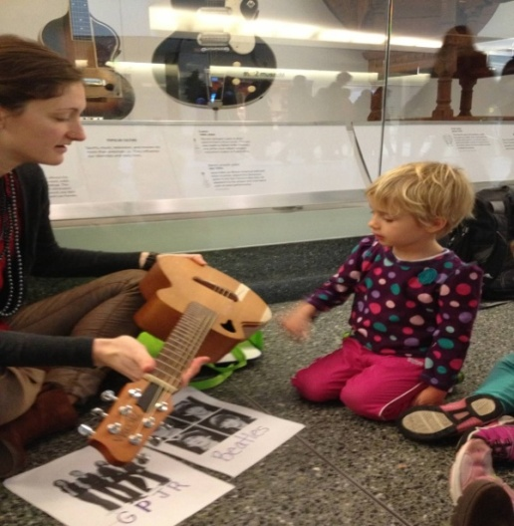
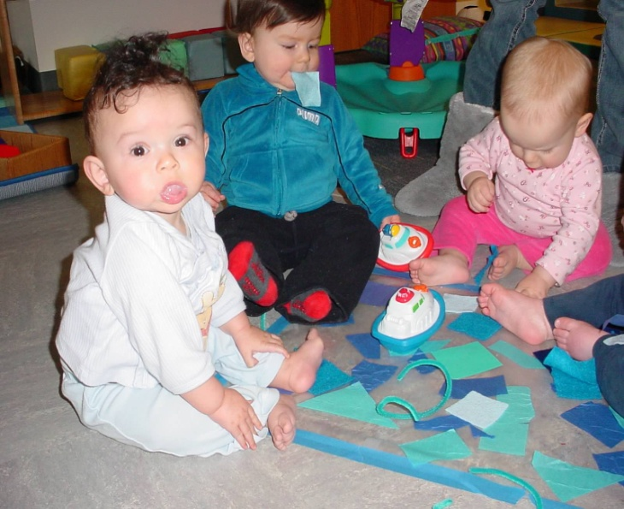

What we believe about learning
At SEEC our focus is on learning rather than on teaching. By focusing on what and how we want children to learn, we can design experiences that facilitate this learning in ways that are developmentally appropriate.
- We believe that learning is a personal search for meaning and happens best when it is intrinsically motivated.
- We believe that learning is best transferred across real life situations when there is an emotional connection built between the learner and the information.
- We believe that providing multisensory experiences opens the opportunity for more connections between the children and the information.
- We believe that learning is deeper, richer and more relevant when it moves out of the classroom and into the community on a regular basis. We believe that people make sense of their world in many ways and that museum and community resources improve the opportunity for sense making.
- We believe in sitting with questions and providing time to search for explanations. We encourage children to think deeply, often, and in new ways.
- We believe that teachers are learners too. In order to teach most effectively we believe they need to venture into unknown, and possibly uncomfortable, areas.
- We believe that risk and failure are just as important as success in learning.
- We believe in the power of shared experiences for learning. We value relationships and their role in learning.
- We believe that learning takes time.
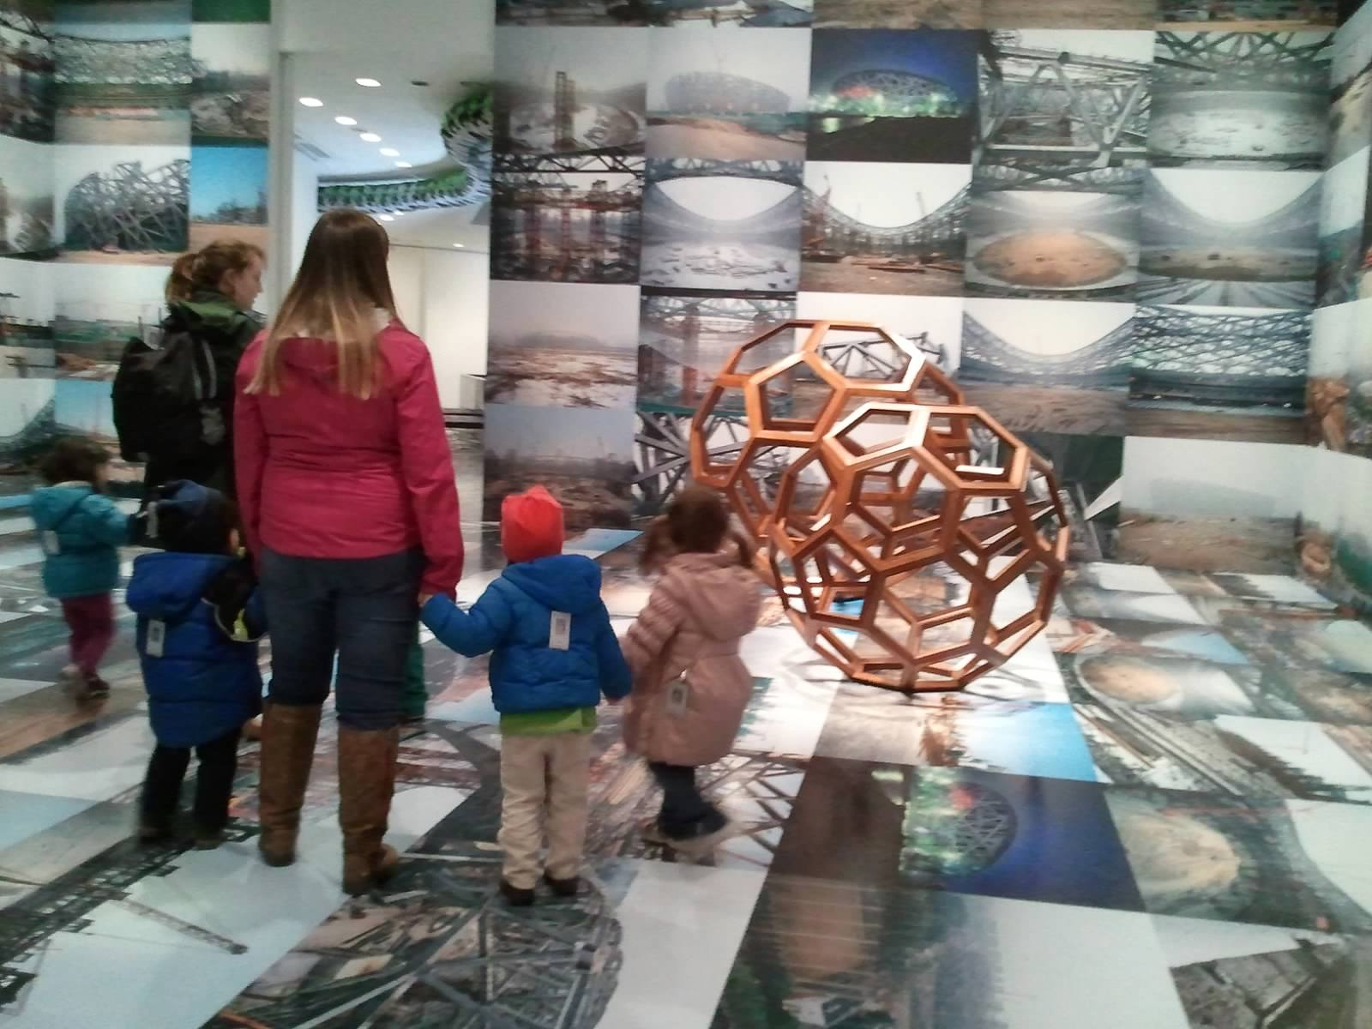
What is our purpose?
- We build a love of learning and a sense of wonder in children.
- We encourage a mindset of curiosity and innovation and foster critical and flexible thinking.
- We build and encourage persistence, imagination, appreciation, and careful listening and observing.
- We teach children how to access knowledge rather than simply accept facts. We want children to become self-motivated learners, to see themselves and the world around them as a constant source of knowledge.
- We prepare children to be full participants in their future school experiences and to move toward being full participants in our society.
- We create places for children to have real experiences with the world around them, to share those experiences and to process those experiences with others.

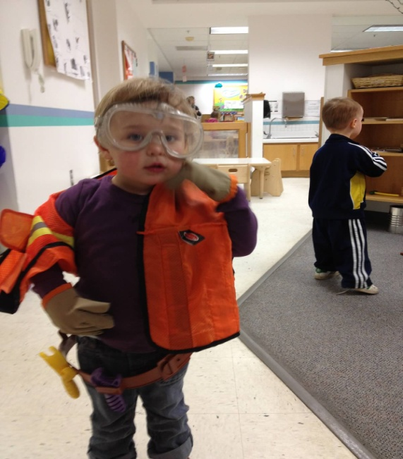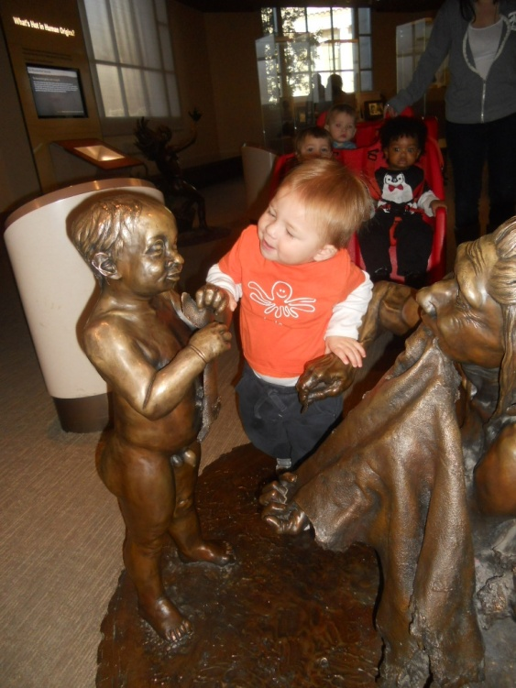

How we do Our Work
These are the strategies we use to achieve our goals. There are three components to what we do: our teachers, our practice and our curriculum. These strategies are based on our beliefs about children and about learning and are designed to achieve our purpose for existing.

Teachers
- We have a team of professionally trained, exceptionally dedicated, and creative teachers who listen to the ideas and questions of children and design experiences to help them pursue these ideas and questions.
- Our teachers document the thinking of children, making it visible to all and serving as a form of memory for the children.
- Our teachers see teaching as part science and part art. They believe it takes hard work, thorough research, thoughtful planning, and deep reflection to provide the best experience possible for children.
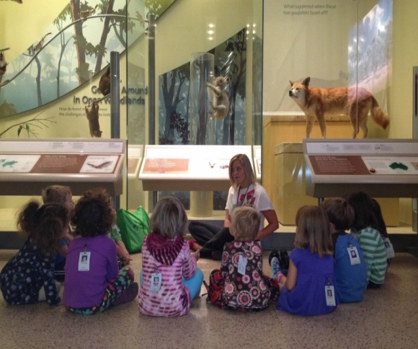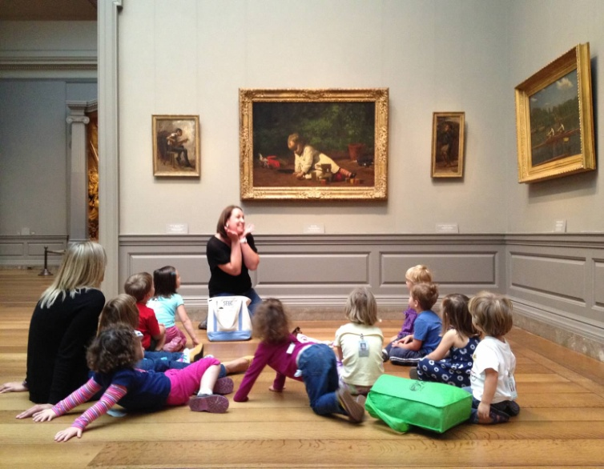

Practice
- We narrate the lives of children and share objects to make these words come to life.
- We build community—with families, with each other, and with the community around us.
- We discuss things from multiple perspectives and challenge our own thinking.
- We encourage children to reflect on their experiences over time.
- We use stories as tools of learning. We use objects, specimens, artifacts, artwork, exhibitions and community resources to tell stories and link the unknown to the known.
- We use discussion, listening, observing, and joint problem solving as forms of teaching and learning.
- We use thoughtfully prepared play opportunities to provide children with ways to explore their ideas and reflect on their experiences.
- We encourage children to build relationships with people and places in our community and across our schools.

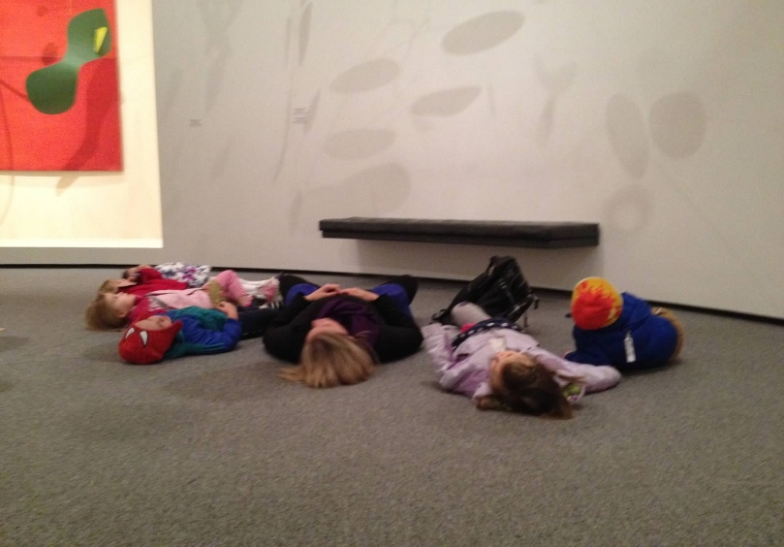

Curriculum
- Our curriculum is designed to build connections between the child’s known world and the larger world around them.
- We present information in context rather than in isolation.
- Our curriculum offers children new ways of seeing, hearing, thinking about, and feeling the world around them.
- Our curriculum uses objects, museums, and community resources to encourage children to gather data, notice deeply, question, analyze, build connections, see patterns, reflect and create meaning.
- Our trips into the community expand children’s ideas and make them more visible.
- Our curriculum uses objects to tell stories, build connections and stimulate thinking.
- Our curriculum uses a combination of teaching methods including open inquiry, guided inquiry and direct instruction as appropriate.
- Our curriculum fully embraces the arts as a basis for teaching and learning rather than seeing them as an add-on experience
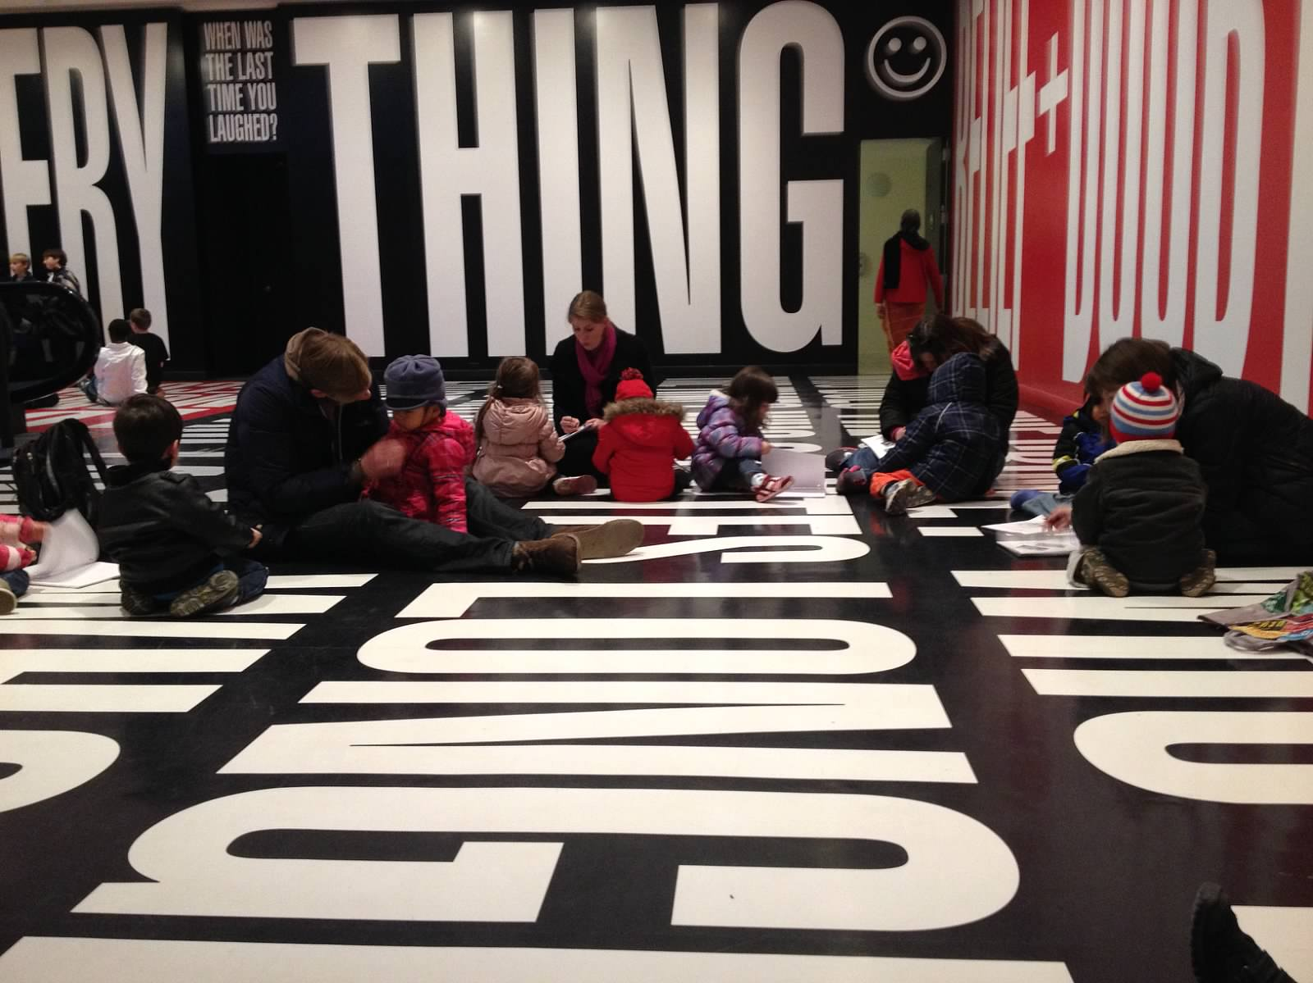

Our curriculum at SEEC is less about a written document and more about all the experiences we provide for children. As a school we focus on larger conceptual themes as a way to organize both the teachers and the children’s thoughts. Under these larger concepts teachers are free to choose the specific topics that best match the interests of the children in their classrooms that year. This allows us to revisit ideas and objects over multiple days, weeks, months and even years. Museum Magic serves as a resource for activities and ideas for planning.
All of the experiences children have with us are carefully planned and developed to make up a comprehensive curriculum. The experiences that make up our curriculum include the following:
- In classroom activities
  - Morning meeting
  - Small Group
  - Large Group
  - Individual
  - Play
- Out of Classroom activities: by extending our work out of the classroom we enable children to discover their interests and get access to knowledge and the tools for gaining knowledge in the community.
  - Regular object based museums and community visits
- Art Enrichment: an addition to the curriculum for 3-4 year olds, art enrichment gives children a space to experiment with materials to represent their ideas and extend their learning. In addition it becomes a place to develop and create exhibitions and collections to further enhance learning. We believe that creating and viewing collections and exhibition are ways to deepen and extend learning.
Across the school and within the classrooms all of our activities are designed to provide experiences that move learning along a continuum from:
- General to specific
- Easy to more difficult
- Familiar to unfamiliar
- Enactive to symbolic
- Self to other
- Concrete to abstract
The daily activities that make up our curriculum emerge from a collaboration of the work of classroom teachers and museum educators. The classroom teachers are experts in early childhood and know their children intimately. The teachers decide on specific curriculum topics for their classroom under the general concept themes based on watching and listening to their children. Teachers consider potential activities to make up specific pieces of the day that will move children along the above continuums of learning.

Museum educators research the museum and community resources that compliment these themes. They search for objects that can come into the classroom or be used in the museums, suggest potential prints that might be useful and help plan visit to the museums or other community resources. In addition, they might also plan in class activities designed to complement a museum visit (ex. Setting up free choice activities or a morning meeting)

Together, teachers and museum educators plan for the following month at a monthly curriculum meeting where they come together to discuss the possibilities. They act as co-teachers as needed, with museum educators implementing activities in the classrooms together with the teaching team as appropriate. Through our curriculum we are trying to bridge the gap between early childhood education and museum education, blending the two in ways that are a model for other schools and museums.
DISCIPLINE AT SEEC

Young children, particularly in group settings, inevitably behave aggressively toward one another at times. When children want the same toy or the attention of the same adult, competition and strife are bound to occur. An irritable or angry child may lash out at another child without any apparent provocation. Physical aggression is not tolerated at the center and adults immediately intervene. How this is dealt with differs depending on such factors as the age of the child, the intent or extent of the aggression and the interactive histories of the children involved. Physical discipline is never used at the center. Instead the staff will help the children to develop an understanding of appropriate ways to express feelings and assist them in developing strategies for social interaction. If, in the opinion of the Director, a child has repeatedly demonstrated disruptive, violent, or deviant behavior, the Director will meet with the parents to discuss strategies for handling the problem. Under extreme circumstances, when the safety and well-being of other children may be in jeopardy or the activities of the center are repeatedly disrupted, a child may be dismissed from the center.

Once you enter the classroom the teachers consider you to be “in charge” of your child in terms of discipline. Please do not discipline or comment on another parent’s child when you are in the classrooms. If you have a concern about a child’s behavior please speak to the teacher in charge and let the teacher take care of the issue. Teachers are not able to discuss information about a child with anyone other than the child’s parents.

What we believe about children
- We believe that young children want and need limits in their lives.
- We believe that children are inherently good, it is their behavior that is sometimes inappropriate.
- We believe that we earn respect and trust from children by showing them respect and trust as well.
- We believe that when children trust adults they are more likely to follow their direction.
The role of discipline in the lives of children
- Discipline is supposed to teach, not punish.
- Discipline should ultimately result in the child internalizing the limits and behaving accordingly.
- Discipline is a way for children to learn about their emotions and to learn to manage them appropriately.
- Discipline should encourage and develop critical thinking and decision making skills.
- Discipline prepares children for living in the larger world in ways that are productive and safe.
- Discipline should help children figure out their own ways of managing their behaviors rather than being the thing that controls those behaviors.

SEEC’s Discipline Practices
- Good discipline requires a menu of potential options ranging from behavior modification tools to conversation, from time out to redirection.
- The choice of discipline method to be used is situational---it depends on the particular child, in the particular circumstance, on a particular day.
- When we discipline children we view it as a teaching experience just like any other teaching experience during our day. Our goal is always to teach in a way that a child can internalize the behavior.
- We model expressing our feelings and encourage children to do the same.
- We use “I” statements to take ownership for our own feelings and concerns rather than assigning or accusing (ex. I am concerned you are going to fall and hurt yourself vs You need to get down)
- We offer choices only when there is truly a choice to be made
- We ask questions only when it is really a question. For example, Can you put your coat on? Is not a real question—you want them to put the coat on and should tell them to do so.
- We use a variety of methods:
  - Explaining: useful when the behavior is disruptive but not dangerous or when the behavior is something the child may not yet know is inappropriate
  - Negotiating/Offer choices: only when there is a real choice or something that is truly negotiable.
  - Behavior modification tools: useful for difficult behaviors that are very disruptive or potentially dangerous or in situations when there is ongoing negative behavior
  - Ignore: useful when behavior is not dangerous but is annoying (tantrums, etc)
  - Redirecting: useful for very young children or when children are tired, hungry or doing things that are not dangerous
  - Stopping: useful when behavior is potentially dangerous or totally unacceptable due to potential danger (ie. Stop now)
  - Holding: useful when a child is out of control as a way to help them self calm and regain control
- We have five basic questions that we ask children to help them learn self control:
  - Is your behavior helpful?
  - Is your behavior safe?
  - Is your behavior disrupting the classroom?
  - Is your behavior healthy?
  - Is your behavior respectful?
- During the infant and toddler years we will point out that a behavior is not one of the above rather than asking the question. This creates a base of knowledge in their brain for the future. As children turn three we begin a combination of asking and telling as they work toward being able to identify their own behaviors. By four we should most often be using the questions as children internalize acceptable and unacceptable behaviors.
Additional Information for Infants, Toddlers and Two Year Olds

Diapering
- Diapering procedures must be followed by staff and parents alike. Each new parent will receive a copy of the diapering procedures, and these are also posted above the changing areas. These policies are established for the health of the children and the necessary control of disease in the Center. If a parent is uncomfortable following the procedure, a staff member will be glad to change the diaper.
- Our expectation is that the parent will ensure that a child begins their day at the center with a clean diaper. At the end of the day, diapers will be changed by SEEC staff just prior to pick-up time.
- Disposable diapers and wipes need to be supplied by the parent. We are unable to accept cloth diapers.

Infants/Toddlers/Twos Supplies
- Blanket 1 lightweight
- Infants – 2 to 3 crib sheets (small crib size)
- Clothing at least two or three sets if child is not completely potty trained
- Small stuffed animal for naptime
- Diapers (disposable only) / Wipes
- Bottles for Infants and Toddlers and Infants (we will provide drinks in cups; if your child needs a bottle at lunch time, please send the bottle already prepared)
- Lunch and snacks will be provided for children who are eating table food; if your child is unable to eat the catered lunch, please discuss this with the Site Director.

Please label ALL clothes; diaper containers, wipes, blankets, pacifiers, etc. before sending to the Center. Use your child's first name and last initial.

Additional Information
- Children will not be permitted to walk around with pacifiers or bottles or to walk around while eating.
- Please do not place purses, backpacks, or briefcases within children's reach when dropping off or picking up since they often contain common objects that may present a hazard to young children.
- Coats should be left at the front of the Center, in the entry or hung on wall hooks, inaccessible to young children.
- Parents entering the infant rooms should either remove shoes and leave them outside the classroom or put blue shoe covers over their shoes before entering. The babies spend their day on the floor playing and interacting and we want to keep it as clean as possible!

ENROLLMENT AND TUITION POLICIES

Any child shall be eligible for admission to the Center without regard to race, color, creed, national origin, gender, or job position of the parent. The SEEC program strives to serve all interested families within the Smithsonian community and provides enrollment advantages for children of employees.

Application and Waiting List
All applicants must complete an initial Enrollment Application Form and pay a non-refundable application fee of $50 (for most families) to be considered for enrollment. A sliding scale based upon place of employment and family income dictates the application fee. Applications are reviewed and placed into age appropriate categories divided by employment status of parents (ex. Infant spaces for SI employees, federal employees and general public employees are three separate lists). On March 1 of each year children will be chosen based upon a random number lottery system. Applicants not chosen for enrollment will be placed on a waiting list in the order of the numbers drawn for the remainder of the school year. For waiting list children, a reduced fee will be charged to reapply in future years.

Registration Fee
Once children are selected for enrollment, parents are required to pay a $100 registration fee. This fee is non-refundable.

Admission Forms
Upon acceptance into SEEC, parents will also be required to complete an enrollment agreement, submit a health form, personal developmental history, release authorization, emergency information form, and emergency evacuation form. The enrollment agreement and all attached forms must be submitted prior to the child's arrival at the center. No child will be admitted without a current health form (dated within one year), up-to-date immunization record based on DC licensing standards, and other required paperwork.

Deposit
A deposit is required for all children enrolling in the SEEC program. The deposit fee is $500 except for children receiving financial aid where the fee will be $300. The deposit must be received by the center to confirm enrollment. Deposits will be refunded when a child leaves SEEC, assuming there are no outstanding debts to SEEC, and if the center receives six-week written notice prior to the child's withdrawal. Written notice should be given to the Executive Director. If a child is newly enrolled for the fall semester and withdraws from SEEC prior to fall, the deposit will not be refunded. The deposit is non-refundable in case of early (without 6 weeks notice) withdrawal from the Center.

Enrollment
At the time of enrollment, infants and toddlers are offered a space in classrooms based on the child’s chronological age. It would be at the discretion of the Executive Director to make an exception to the policy for placement of a child based on chronological age. Two-, three- and four-year-olds are offered a space based on the number of openings in the age based classrooms.

In the spring of each school year, teachers and administrators discuss placement of children for fall. In cases where the child’s development warrants a placement that is not necessarily the next step sequentially, parents will be notified of SEEC’s recommendation. Placement is at the discretion of the Executive Director.

Enrollment Schedules
At the time of enrollment, a child is offered a space which is either full-time or part-time. Both parties understand that a change in schedule is at the discretion of the Executive Director. A request for a change in schedule should be made in writing to the Deputy Director for Operations or the Executive Director. Approval is based upon the availability of space and the priority for the space. Each spring requests for schedule changes for the upcoming year are reviewed. While every effort is made to accommodate the requests, there is no guarantee that requests can be honored.

Spaces offered to families in infant classrooms will be held for 12 weeks following the birth of the child or until the designated start date for the child if the child was born prior to summer. While a family may certainly choose to stay home with an infant longer than the 12weeks payment for the space will need to begin at the 12 week mark in order to assure your space.

Infants and toddlers will be accepted only with the financial commitment of a full-time space. A limited number of part-time slots may be available for children two and older.

Health Certificate
Before being admitted to the Center (and minimally once a year thereafter) each child must have a medical examination and immunizations, as required by DC law. The Health Certificate for the examination and immunizations must be completed by a licensed physician and submitted to the Center before enrollment. It is the responsibility of the parent to maintain an updated health form. In the case of an expired Health Certificate, a parent will be asked to keep the child at home until an updated form is submitted.

Each time that a child has a health physical, a parent should request a form from the center so that an updated copy can be submitted. A health form expires one year from the date of the examination. Younger children require more frequent checkups to receive necessary immunizations. Records of immunizations should be updated by the physician’s office and returned to SEEC by the parent. Please note that SEEC is required to follow DC immunization policy which does not always align with other state recommendations for immunizations.

Dental Certificate
In addition to the required health certificate, a dental health certificate is required for all children over the age of three years. Prior to admission, parents of children enrolled in the preschool program must submit the required form (and each following year), as required by DC law. For children who turn three in the course of the school year, parents must submit a dental health certificate within two weeks of the child’s third birthday (and minimally once each year after). It is the responsibility of the parent to maintain an updated dental health form. Failure to provide the required dental health assessment will necessitate that a child stay home until the required form has been submitted.

Re-enrollment Process for SEEC Children
Each spring, current SEEC children are given the opportunity to enroll for the following school year. To confirm enrollment, a payment [prepaid tuition] of $300 is required in the spring and will be applied to the first tuition payment in September. Failure to submit the prepaid tuition payment in the required time frame will result in forfeiture of space for fall.

If a child withdraws from SEEC prior to fall, the following guidelines apply for the refund of the payment. All requests for refunds must be submitted in writing to the Deputy Director for Operations or the Executive Director. Those submitted prior to May 1st will result in a $100 penalty; requests made between May 1st and May 31st will result in a $200 penalty. Notification of withdrawal on or after June 1st will result in forfeiture of the entire prepaid tuition.

Sibling Policy
Priority status is given to siblings of currently enrolled SEEC children of Smithsonian employees. At the time of the application for enrollment, a child will receive the above stated sibling status if:

(1) the brother or sister is currently enrolled at SEEC and
(2) an opening in the center is available so that enrollment of both siblings is concurrent.

Sibling preference does not extend to a sibling for fall enrollment if the older sibling is scheduled to leave SEEC before the fall semester begins. If no openings are available for immediate entry to the center, a sibling will be placed on the Sibling Waiting List and will remain there until that time when the brother or sister leaves the center. Infant siblings will be given priority for enrollment as long as the older sibling remains enrolled at SEEC. If the older sibling withdraws from SEEC prior to the start of the school year, including for the upcoming school year, the offer of an infant space will be withdrawn and the infant’s application will be re-entered into the lottery. It will be eligible for reselection by lottery for that space, along with other applications in the same category.

Waiting List Fee
If a space is not available at the time of application, a child's name can be submitted for future consideration of enrollment with payment of the appropriate non-refundable application fee. Fees are on a sliding scale.

Children with special needs
The Smithsonian Early Enrichment Center welcomes children with diverse needs and seeks to support their growth through personalized interactions and collaboration with parents and external educational experts. Educators at SEEC modify practices for children with special needs within the classroom, but assist parents in finding outside experts and specialized programs when a child’s needs cannot be met within the SEEC program. All 3, 4 and 5 year olds are screened for developmental issues as part of the beginning of the school year and 4 year olds receive vision and hearing screenings in the spring of each year

TUITION AND FEES

Tuition is paid on a biweekly basis using a Tuition Debit Agreement with each parent. Tuition will be debited directly from the parent’s bank accounts every other Friday as outlined in the payment schedule given to parents for annual payments. An overdraft will result in a charge of $35. To redeem a debit returned by the bank, the amount of the debit and the penalty charge must be paid either by certified check or money order. A pattern of bad debits will result in certified check or money order payments only and may, under extreme circumstances, result in your child's termination from the center. The Center also has the right to terminate enrollment if a parent’s pre-authorized debit account is closed without written notification from the parent to SEEC.

Each parent is given a list of tuition due dates for the year and is responsible for payment through the Tuition Debit Agreement. Tuition payment #1 should be paid by check or money order. Tuition payments are due for all days, including holidays, with the exception of the one-week break in August. The center is not responsible for any payments lost, stolen or misplaced before delivery to the Director.

The weekly tuition rate is subject to change by the Board and is reviewed annually. In the rare situation that a mid-year rate change should occur new rates may go into effect as early as one (1) month after notice has been provided.

You are responsible for paying the full tuition for each week that your child is enrolled in the center even if your child is absent (due to illness, vacation or other cause). Any child with outstanding debts as of August 10th will not be permitted to enroll for the fall term.

Non-Smithsonian Fee
A fee of $1500 per year for full-time (pro-rated for part-time) is charged for each child from a non-Smithsonian family. The Smithsonian's Office of Human Resources determines Smithsonian or non-Smithsonian status. To support the Smithsonian staff, the Institution contributes to the SEEC organization by providing space and in-kind services. The non-Smithsonian fee is charged to families representing outside agencies or businesses.

FINANCIAL AID POLICY

It is the philosophy of the Center that no child be denied admission because of a parent's inability to pay the entire tuition. To that end, a scholarship fund has been established to provide tuition assistance for children of families with a demonstrated financial need.

In 2001, an endowment fund to support scholarships was created through an initial gift of $100,000 from the Smithsonian Institution and was designated for families at Grade 8 and below. A second scholarship fund consists of generous annual grants from numerous organizations, including donations from the Parents Association fundraising events and gifts from other individuals. Earnings from SEEC’s Educational Outreach Program also provide support for financial assistance.

To qualify, parents are required to submit a separate and confidential financial aid application, including copies of federal income tax returns, for review. To apply for financial assistance, contact the SEEC Executive Director or download forms from the SEEC website. During the 2013-14 school year SEEC will be exploring new services to better review and analyze information submitted. If extraordinary expenses or other factors are not reflected in the income tax returns, applicants are encouraged to explain these circumstances in a cover letter accompanying the scholarship application. Recipients of scholarships must reapply for scholarship each year and provide a copy of the latest tax return.

Withdrawal from the School
For current SEEC children, a six-week written notice is required to withdraw a child for any reason other than illness. This notice is required to enable the center to fill the child's vacancy. Failure to provide proper and timely written notice shall result in the forfeiture of the initial deposit. For those families who have accepted enrollment for the fall semester, withdrawal after June 1st (prior to the actual start date) will result in a forfeiture of any deposit paid.

Termination by school
The center reserves the right to terminate a child's enrollment immediately, if any of the following conditions arise:

- In the judgment of the center's Director, the child's behavior threatens the physical or mental health of other children in the center;
- repeated delinquency in payment of tuition;
- consistent forms of bad payment;
- the child is repeatedly picked up late.

In keeping with our philosophy to best accommodate the needs of the children and parents, we constantly watch to be sure your child's needs are being met. If concerns exist, the parents will receive immediate on-going counseling and support. In cases where a problem cannot be resolved, the parents will be given a two-week written notice for termination. If enrollment is terminated due to the child's behavior, you will receive a refund of the deposit and a portion of the tuition fee, pro-rated on a daily basis for the period paid. If enrollment is terminated immediately for any other cause, the center will refund the appropriate portion of the remaining bi-weekly tuition fee, but will not refund the deposit. The center may terminate a child's enrollment upon two weeks prior written notice to you if any of the following conditions arise:

- Any of the conditions above, assuming the center has not terminated immediately;
- In the judgment of the center's Director, the program does not meet the developmental needs of your child;
- You fail to abide by the terms of the Enrollment Agreement and Parent Handbook.

HOURS, HOLIDAYS AND CLOSINGS

All SEEC centers are open on weekdays from 7:30 a.m. until 6:00 p.m. unless noted in the yearly calendar.

Hours
All children are expected to arrive prior to 9:00 a.m. for the beginning of the morning activities. This is essential for both your child and the others in the class. Throughout SEEC, parents will be responsible for finding their child's class if the classroom has left the building for their museum visit.

You are strongly encouraged to have your child at SEEC no more than nine and one half (9.5) hours in any one day with the exception of kindergartners. Long days become very difficult for young children and may be the difference between a child having a positive experience or a stressful experience.

Teachers are unable to accept children into the center prior to the scheduled opening time. In the evening, parents should attempt to arrive by 5:45 so that a parent will have adequate time to prepare a child for the trip home. Our doors are to be locked at 6:00 p.m.

Holidays
The Center will be closed on all holidays observed by the Federal government and other holidays approved by the SEEC Board of Directors. Refer to the full calendar in Appendix B for all important closed dates and meeting dates.

School Closing
The Center is closed for the one week prior to Labor Day. Tuition payments are not assessed for the week the center is closed in August. Staff members returning in September have paid vacation time during this week as well as time for preparing their classrooms for the upcoming year.

Any closing for weather or other emergency situation by the Smithsonian Institution will also include the center. No refund or credit against the tuition will be made for closures by SI. Tuition fees are not changed for scheduled holidays or any other center closings, except for the one-week closure in August.

Involuntary Closing Policies
If SEEC is involuntarily closed due to budgetary or other issues affecting the SI as a whole, parents will continue to pay full tuition if that closure is for a period of one week or less. If SEEC is involuntarily closed for a period of time greater than one week, parents will not be required to pay tuition beyond the first week unless the involuntary closure is the result of a government furlough and salaries are retroactively paid.

Inclement Weather Closings

SEEC will be OPEN if the Federal Government is operating on a regular schedule.

SEEC will be CLOSED if the Federal Government is closed.

SEEC may operate on a LIMITED SCHEDULE when the Federal Government announces unscheduled leave, adjusted home departure, or any other approved late arrivals. In some cases of unscheduled leave (depending on the reason), SEEC will open at 9:00am, while in other cases SEEC may choose to open on time at 7:30. Parents will be notified by email prior to 6:30am if we are opening late. If you do not receive an email by 6:30am you should assume that we are opening on time as usual. The same is true for cases of adjusted home departure when SEEC will close between 4:00 and 6:00 depending on weather conditions such as icy roads, snow, or sleet. Parents will be notified by e-mail prior to 3:00 p.m. about closing time for the day. If parents are uncertain about closing time, it is their responsibility to contact SEEC to confirm closing time or arrive at SEEC by 4:00 p.m. While we will stick to these policies as much as possible there may be times when the Executive Director determines that a different course of action is appropriate. Parents will be informed of any changes in policy via email from the Deputy Director or Executive Director.

If the Federal Government announces an early close during the workday, SEEC will remain open for 1 hour following the announcement. During inclement weather, parents should provide contact information to allow easy communication with parents should an early closing arise.
SEEC SECURITY PROCEDURES

Security Contact Information

American History Museum
- Gary Boyd: Security Manager
Mr. Walker: Second in Command
- SI Emergency Command Center (ECC) location: Presidential Suite, 1st floor
- Alternate ECC: Security Office Room AB050, on the basement level
- Off-Site ECC: Paul Garber Facility, Building 19, NMAH Off- Site Storage Facility
Natural History Museum
-Carl Taylor: Security Manager
William Branch: Second in Command
- SI Emergency Command Center: Room CEG09
- Alternate ECC: ECB15
- Off-Site ECC: MSC Room C1000
SI Emergency Central Information: 202-633-3988

SEEC Emergency Line of Succession

- ECC Commander Line of Succession: The following persons are pre-designated and listed in order of succession:
EXECUTIVE DIRECTOR: Kim Kiehl, 202-633-1394; cell: 614-338-5228
DEPUTY DIRECTOR: Meredith McMahon, 202-633-1395; cell: 215-266-7269

- The following persons are pre-designated for each SEEC Unit (Center):
AH: Megan McMahon; 202-633-3660; cell: 352-262-5658
NH MAIN/EAST: Melody Passemante; 202-633-4079; cell: 570-772-4999

SEEC Emergency Supplies
Each Center has an Emergency Binder containing:
* Complete and current list of all children enrolled and all teachers employed
* Required emergency plans from all parents and staff
* Emergency Evacuation Plan for each family
* Staff Personal Emergency Plans
* Evacuation Tracking Form: abridged custody release information to record and track time/details of emergency pick-up.
* Current list of children’s SI identification badge numbers.
* Back-up Information:
* Current Emergency Medical and Custody Release
* Family Emergency Evacuation Plan
* Allergy / Medical information

Entering SEEC Buildings

- All SEEC employees are required to wear their SI ID badge when out of the center
- Every SEEC child is issued a SI ID badge that is individually numbered for purposes of emergency identification. Every SEEC child will wear their ID whenever outside their Center.
- A complete and current list of child ID numbers is included in each Center Emergency Binder to facilitate replacement.
- SEEC parents who are not SI employees are also issued a SEEC ID to allow for entry to their child’s school building.
- No adults are to be allowed in any of the SEEC buildings without a programmed badge that allows entry or being accompanied by a SEEC employee.
- Parents entering the American History Center should come in through the right side set of doors forcing them to have to pass by the officer and have their badge checked before swiping it at the SEEC entrance. Parents at Natural History have to show their badge upon entrance to the museum and then pass to the centers where they will need to swipe their badge for entrance to the centers.

Classroom Communication when Outside the Classroom
All groups leaving the Center are required to carry a security radio (provided by SI OPS). Radios are tuned to SEEC frequency and have ability to use SI frequency to contact SI OPS directly if needed.

All groups leaving the center are also required to carry a Classroom Emergency Bag that includes:
- First Aid Kits; Flashlight; Tissues; current Emergency Medical and Custody Release forms, Family Emergency Evacuation information for each child in the Center, and any necessary medications for children with identified allergies (Epi-pens & permission forms).
Each classroom is required to sign out at the Center before leaving with the time they left the center and their destination. At Natural History teachers are also required to sign out at the Security Desk located on the Constitution Avenue side of the museum. All teachers should have at least one cell phone with them and on at all times when away from their center. This phone can be used for emergency phone calls to the center or to 9-1-1 as needed.

Fire Evacuation
Regular fire drills are held to ensure that all staff and students are familiar with the school’s emergency fire response plan. For Fire evacuation purposes the following describes the children to be evacuated from each center:
- AH: 4 classrooms of 52 children total, all are able to walk on their own
- NH Main: 4 classrooms of 37 children total; two classrooms are able to walk on their own; two classrooms contain infants that must be transported by cribs (4 cribs of 4 children/crib).
- NH East: 3 classrooms of 40 children total; all are able to walk on their own

In the event of a fire teachers should immediately evacuate the site upon discovering fire or hearing the designated signal (e.g., fire alarm bells) and proceed to the designated assembly area and remain until further instructions are received from SI OPS, or the Executive or Deputy Director of SEEC.

Administrators should notify SI OPS if the fire alarm signal has not sounded and there is a fire in the building and assist with the evacuation of remaining staff and students to the appropriate assembly area. If the alarm system fails to operate, administrators are to notify staff and students by other methods. Administrators also are to supervise evacuation of the school and confirm that all rooms and areas are evacuated.

Emergency Response Instructions
In some emergency situations SEEC will either shelter in place or evacuate the site. In all of these situations SEEC will follow directives from SI OPS.
- The Executive Director and/or Deputy Director will serve as main point of contact with SI OPS. All directives in an emergency situation should come directly only from SI OPS or from the Executive or Deputy Director.
Site Directors will maintain frequent communication with other SEEC Centers and with the Executive Director/Deputy Director via radio and/or cell phone. They will also serve as main point of contact for parents. Site Directors are also responsible for managing custody release processes for children and families in an emergency situation, including completing tracking forms with time released and custody recorded and providing a copy of tracking form to OPS when evacuation is completed.

In an emergency situation the teachers’ primary job is to remain calm and keep children calm and engaged. If parents are arriving at the center/emergency site, teachers should also keep parents calm in front of children.

PROCEDURES FOR SEEC EVACUATIONS AND SHELTER IN PLACE

During emergencies, SI OPS will dispatch one officer to each of the Smithsonian Early Enrichment Center (SEEC) centers; two located in the National Museum of Natural History (NMNH) and one located in the National Museum of American History (NMAH). The safety of the SEEC children will be considered a top priority of the Smithsonian Institution at all times. The dispatched officer will maintain constant communication with SI OPS who will maintain constant communication with OPS command and will remain with the location until the emergency has been resolved. In the case of an emergency, the SEEC children and staff will either be directed to evacuate the building, shelter-in-place at an optimal location within the building, or be evacuated via a SI vehicle to an alternate location to be determined by OPS command. In all cases, the dispatched officer is to stay with the SEEC children and staff until relieved.

Evacuation of Building
Upon recognition of the need for a general building evacuation in either NMNH or NMAH, and following building evacuation plans, OPSO will dispatch an officer to each SEEC area and accompany the SEEC children and staff to their respective assembly areas. In most cases children and staff will evacuate to the mall area closest to their location. It is the responsibility of SEEC administration to contact SEEC classrooms that are outside their normal classroom areas and either direct them to the assembly area or to take some other action.

In the case of any emergency which requires evacuation of a center, the staff and children will proceed outside to the mall. If an immediate return to the center does not seem likely, the children will be taken to an empty room in the Quad. If the Quad is not considered a safe alternative, the children will move to an alternative space assigned by SI OPS. Emergency backpacks are to be carried with each group so parents can be contacted as to time and location of pick up.

In the event of a major emergency evacuation of the mall, consultation with SI OPS personnel will provide information for the Executive Director and/or Deputy Director to determine closing and plan of evacuation. Parents will be informed of these plans via the SI Alerts system and should contact the building security office if they are unable to reach the center during an emergency.

Shelter-in-Place
Upon recognition of the need for building occupants to shelter in-place, and following building shelter-in-place plans, OPS will dispatch an officer to each SEEC area and accompany the SEEC children and staff to their respective shelter in-place areas within the building. It will be the responsibility of SEEC administration to contact SEEC classes that are outside their normal classroom areas and direct them on an appropriate action. Specific emergencies may require different locations within the building for SEEC to obtain optimal shelter-in-place protection. For example, high wind events will require that SEEC shelter-in-place in a windowless room/area that minimizes damage or injury from wind-driven projectiles. A chemical emergency either inside or outside the building will require that SEEC shelter-in-place on an upper floor of the building to avoid heavier-than-air chemicals that will settle in low-lying areas. A criminal or terrorist event may require an alternate shelter-in-place location that will be determined by OPS and transmitted by the dispatched officer to the Executive or Deputy Director. SEEC staff will be responsible for transport of any needed materials (e.g., diapers, formulas, etc.) for a prolonged shelter-in-place emergency.

In the case of a shelter in place situation each center should have the following supplies on hand:
* Emergency water supply
* First Aid Kit
* Adequate snack foods for Shelter-in-Place of 5-6 hours
* Classroom Emergency Bags containing First Aid Kits; Flashlight; Tissues; current Emergency Medical and Custody Release forms, Family Emergency Evacuation information for each child in the Center, and any necessary medications for children with identified allergies (Epi-pens & permission forms
*Supply of diapers and or PortaPotty in area in case shelter in place does not allow use of bathrooms
In the case of a prolonged shelter in place and agreement with Restaurant Associates has been arranged to provide food as necessary.

Evacuation of SEEC by Vehicle
In the case of an emergency that requires SEEC to evacuate the Mall via SI vehicles, OPS command will contact the OFMR Transportation Division and request that resources be made available to transport the SEEC children and staff to a suitable location to be determined by OPS command. In addition, OPS command will direct OPS to dispatch an officer to each of the SEEC areas and assist with the transportation of all SEEC children to the vehicles that SI has at its disposal. OPS at NMNH and NMAH will have keys to the needed vehicles. Shuttle buses may be used for this purpose, but alternate resources located at NMNH and NMAH may be used instead. Either SI staff or SEEC staff may be used as drivers for these vehicles. In either case, the drivers will be directed to a specified safe location by OPS. In addition, all drivers will have communication devices (SEEC radios and cell phones) for transmittal of vital information during the event. It will be the responsibility of SEEC administration to contact SEEC classes that are outside their normal classroom areas and direct them on an appropriate action. SEEC staff will be responsible for transport of any needed materials (e.g., diapers, formulas, etc.) for a prolonged journey to a safe location.

SEEC teachers are responsible for knowing what the emergency procedures are for museums they are visiting. SEEC teachers should always be aware of potential shelter-in-place actions to be taken for a variety of emergency situations in the museums. OPS will assist with training teachers as needed.

If an emergency situation occurs while a classroom is visiting a museum either a SEEC teacher or SEEC administrator (to be determined when the SEEC teacher radios the center) will get word to the Security Office/Officer in the museum that they are visiting the museum and their current location at the time of the emergency. If the classroom is at a mall location the security officer assigned to SEEC from NMAH & NMNH should respond to that museum if at all possible (depending on the type of emergency) teaming up with the teacher and escorting them back to their home museum. If classrooms are in multiple museums at the time of an emergency SEEC administration will work with the officer assigned to the location to determine the best way to get children back to the center or the best course of action.

Media Relations
Emergency situations often bring a throng of media with them. It is important that teachers and Site Directors do all they can to protect the children from the Media in the case of an emergency. Requests for comment from the media should be answered with “No comment. You will need to speak to our Executive Director.” SEEC staff and parents should NOT post any information, comments or photos on any social media including Facebook, Twitter or any other social media sites. The Executive Director shall serve as the single media contact for SEEC and will coordinate with SI and/or museum media resources and will refer media to the media site set up for the emergency. In the case of the absence of the Executive Director, the Deputy Director will take on this role.

SEEC teachers and Site Directors should not engage with the media but should direct all media inquiries to the Executive Director. The Deputy Director and the Site Directors will receive updated information regarding the status of the emergency situation from the Executive Director and/or members of the SI OPS team. In any situations involving the response of SI OPS, all press releases/media contacts shall be coordinated with the Smithsonian through the Executive Director.

Weather Emergencies & Natural Disasters
Serious threats exist related to hurricanes, tornadoes, earthquakes and major storms. In case of severe weather, SEEC staff will be notified via the SI Emergency Alert System. If action is required, SI OPS will send an officer to each of the three sites to direct staff to a safe site for the particular weather situation. The SI OPS officer will remain with the students and staff until the emergency is passed or until the group is safely sheltered. SEEC staff are to ensure that students are safely evacuated and help students remain as calm as possible. SI OPS will provide the “All Clear” signal to return to the buildings once the warning has been lifted.

Lost Child
If a SEEC child is lost in any of the SI museums the teacher should immediately notify a security officer from the museum, providing all pertinent identifiable information. The museum will then initiate a CODE ADAM. The teacher should also immediately radio their center with this information. If the loss occurs off Smithsonian property the teacher should notify the museum security, the nearest Law Enforcement officer seen, or immediately call 911 if neither option is available. The teacher should also immediately radio their center to coordinate action.

Bomb Threats/Explosions
All bomb threats must be taken seriously, even though telephone calls, e-mail messages or other types of communication stating there is a bomb on the premises are often not real. Sometimes callers feel a certain power by causing a site to be evacuated but since we have no way of knowing whether a bomb actually exists each bomb threat should be handled in a calm and consistent manner, following established procedures and guidelines. Safety and the prevention of panic are of paramount importance.

Telephone, Fax or Email Bomb Threat
Most bomb threat calls are brief. SEEC staff who receive a bomb threat via one of these means are to:
-Stay calm and be courteous. Try to keep the bomb threat caller talking. If email or fax, print or forward the message to the Executive Director and notify the Site Director, Executive Director or Deputy Director immediately.
-Ask the caller for a specific bomb location and what time the bomb is set to detonate. Gather as much information as possible.
-Try to signal a co-worker to listen to the telephone conversation, if possible.
-Record information in writing while on the phone if possible.
-Listen for background noises. Listen closely to the voice for any identifying information (accents, speech impediments, etc)
-Immediately notify the Site Director, Deputy Director or Executive Director.
-Turn off all radios and cell phones because they may activate some types of bombs.
The Site Director should call the Executive or Deputy Director and their site OPS personnel immediately. The Site Director and Executive/Deputy Director will coordinate with SI OPS to evaluate information received and decide upon a course of action.

SI OPS will initiate and direct a search or evacuation of the site. Directives for evacuation will come only from SI OPS, SEEC Executive Director or SEEC Deputy Director.

Suspicious Package or Device Found
Any SEEC employee who finds a suspicious package on a SEEC site should follow these procedures:
-Do not touch or disturb the package.
-Do not transmit with a cell phone or a radio in the vicinity of the suspicious package because these devices may activate some types of bombs.
-Immediately notify the Site Director and/or the Executive/Deputy Director of the exact location and description of the package or device.
-The Executive Director or Deputy Director will contact SI OPS for further instruction.
-In the case of an evaluation each center will utilize the site evacuation plan or site fire drill procedure to move all staff and students away from the suspicious package. A minimum of 500 feet is recommended.
-Upon arrival, SI OPS personnel will assume responsibility. All investigations will be conducted by SI OPS officials.

Explosions
Upon hearing an explosion, immediately take cover under or next to furniture. Try to remain as calm as possible. Try to identify what may have exploded, the extent of the damage, and any possible life-threatening hazards to determine the next course of action. Contact the Executive Director, Deputy Director or Site Director immediately. If a SEEC classroom is out of their building and an explosion occurs they should contact their center as soon as safely possible via radio to determine their next course of action.

If told to by SI OPS, evacuate according to the site plan. Otherwise, remain in place of cover until told to move by SI OPS, the Executive Director or the Deputy Director at SEEC.

Teachers and administrators should ensure that no one returns to the site of the explosion for any reason until SI OPS personnel officially declare the area safe.

Active Shooter
Although shooting incidents are rare, high-profile shooting incidents that have occurred have brought to reality the threat potential that exists on any public space in the United States.
Each situation will be unique and will require SEEC teachers and administrators to think on their feet and respond accordingly. Actions will also depend on whether the shooter is in the building, on the mall or in the area. SEEC teachers or administrators should immediately contact each other by radio should an active shooter situation occur while classrooms are out visiting museums so appropriate actions can be determined at the time. If there is not time to use the radio before responding SEEC teachers should use their best judgment based on active shooter training they have received from OPS. Actions may include locking down or moving away from the situation but it is impossible to provide a standard way of reacting since it is so situation dependent. In all cases an security officer will be sent to each SEEC site until the situation has been resolved.

It is important to note that in an emergency, parents may NOT be allowed to come into the building and get their children if that building has been ordered into a lockdown. Parents will be communicated with using the emergency notification system and it is vital that they follow the instructions sent in these messages. Teachers will also receive these messages so should keep cell phones with them in any emergency situation. SEEC will not release the children until law enforcement /OPS makes it clear that children and or staff can leave the building. This is especially true in an active shooter situation.

Disruptive Person on Premises
Individuals who enter the school and become disruptive can pose a threat to the safe environment of our school and should be dealt with carefully. If the disruptive person is a parent or other person authorized to be in the building contact the Site Director and inform them about the persona and your concerns. If necessary, the Site Director will request the individual to leave the center. Should the individual not comply, the Site Director should contact SI OPS and attempt to manage the situation calmly while waiting for OPS officers to arrive.

Student Injuries
SEEC staff may treat minor injuries. Emergency medical personnel are to be called where there is any indication of serious injury or potentially life threatening situation . Parents/guardians are notified whenever there is any degree of injury.

Any time a student receives a minor injury, the classroom teacher should treat the injury and complete the Ouch form or the accident report form. The teacher will notify the Site Director as soon as possible of the injury. The teacher or Site Director will normally notify parents/guardians in the case of minor injuries related to accidents.

In the case of a more serious injury and based upon a determination made by the Site Director and/or parent, the injured student may be transported to the hospital. Depending on the degree of injury and the desire of the parent/guardian, one of the following procedures may be used to transport the student to the hospital or other medical facility:
- The parent/guardian may come to the school and transport the student.
- The student may be transported by ambulance and the parent/guardian would be asked to meet the ambulance at the hospital.
Any time it is determined that a student is in need of emergency medical services, the teacher in charge of the injured student should notify the Site Director who will contact 911 and SI OPS. If the Site Director is not present the teacher may call 911 and inform the Deputy Director or Executive Director of the situation immediately. The Site Director will immediately contact the parent or guardian and ask them to respond to the hospital. The Site Director may assign a staff member to accompany the student depending upon the degree of injury and contact with the parents/guardians.
Emergency Planning Frequently Asked Questions

- The Parent Manual describes Emergency Closing Procedures. How is this different from Emergency Evacuation?

The Emergency Closing Procedures outlined in the Parent Manual only apply if a single building is targeted for evacuation. For example, a fire, bomb threat, or facility problem may necessitate leaving the building. If an immediate return to the center is unlikely, children will be taken to the S. Dillon Ripley Center on Jefferson Drive (the Quad) or to one of SEEC’s other facilities. Parents will be notified by email and phone if possible.

- If the children are in the Quad, how do non-SI parents gain access to the building?

During regular museum hours, the building would be automatically open to the public. Before and after museum hours, parents would be required to show their SEEC ID that is given to all parents at Orientation. It is the parent’s responsibility to have access to his/her SEEC ID for entry to the building. Additionally, SEEC administrators would provide a list of parents to the security guard at the entrance of the building.

- If the children are in the Quad, where do parents park?

There is no special parking available at this location; therefore parents would need to find parking somewhere on Jefferson Drive or other nearby streets.

- In a serious emergency when the city and/or Mall is being evacuated, how will parents be contacted as to the location of the children?

SEEC administrators will attempt to contact parents by (1) group email (2) phone calls from SEEC to parents (3) a message on SEEC’s phones. Parents also have been given phone numbers for contacting SI security offices. If communication is not possible due to the crisis, parents will have to rely on making direct contact with SI security by coming to the museum when it is safe. Security officers in AH and NH security offices and at each entrance to the museums will have information about the location of SEEC children.

- Will parents know whether an emergency has been designated as a Priority I, Priority II, or Shelter in Place code?

If communication is available through email or phones, parents will be notified. If this is not possible, information will be sent out over the SEEC channel of SI Alerts. Parents will not get information through the media about the type of evacuation (Priority Level). If all lines of communication are down, it is likely that it is a Priority I. In any case, parents should attempt to come to the center to pick up their child as long as the parents’ safety is not compromised.

- What happens if no one from a family’s Emergency Evacuation Form is able to get to the center to pick up a child?

Obviously, any children that remain will be the responsibility of SEEC administrators. Every attempt will be made to contact the parents and other authorized persons. If this fails and SI makes a decision that evacuation is required, the remaining children will leave the museum with one of SEEC’s administrators. Attempts to continue to contact parents and leave messages will continue until the connection is ultimately made.

- If children are evacuated on SI shuttle buses due to an imminent threat that requires immediate evacuation, where will they be taken?

While this scenario is highly unlikely, it has been reviewed as another alternative for evacuation under dire circumstances. Based upon the location of the crisis, security will make a decision about the most appropriate Smithsonian destination for the children. Potential sites include (1) Udvar-Hazy Center at Dulles, (2) MSC in Suitland, Maryland, (3) the National Zoo. Again, SEEC will attempt to communicate directly with parents but will rely upon security to maintain information about SEEC status and location for parent access.

- Why is there not a plan in place that is specific about the steps that will be taken in a crisis?

The nature of a crisis (natural or terrorist threat) is that it doesn’t follow any particular pattern or format. There are hundreds of possible situations that can occur and decisions must be based on informed analysis of the individual emergency. Experts will assess the crisis and determine the best course of action given the nature of the specific emergency.

CLASSROOM AND PARENT GENERAL INFORMATION

Teachers
Lead teachers at SEEC have either a Bachelor's degree or Master's degree and experience working with young children. Associate teachers have degrees ranging from a Child Development Associate credential to an AA/BS degree, some have MS degrees in fields outside of education as well. Teaching at the center is a team effort. All planning is collaboration between the teachers, the museum educator, and the appropriate administrators. In addition, the entire lead teaching team meets monthly to insure continuity across the school. Everyone has the same goal, the education and well-being of the children, but each staff member brings individual interests and strengths to the program. Each classroom has one lead teacher and at least one associate teacher depending on the ages of the children. Some classrooms have two co-lead teachers sharing responsibility.

Classroom placement
Children are placed in groups initially based on chronological age. If the placement is inappropriate as determined by the teacher, parents, and Executive Director, the child will be moved to an appropriate group at the first available opportunity. The Executive Director will make the final determination if consensus cannot be reached. Infants and toddlers are placed in classes that have a six-month range in the age of the children. The youngest groups are smallest in class size, with infants and toddlers typically having a 3:1 child to staff ratio. A 4:1 or 5:1 ratio is used for the two-year-old classes, depending on the group. A chart showing the progression of children through SEEC can be found in Appendix E.

The following criteria are used for initial placement of infants and toddlers:
- Cottontails: (children at least 3 months and less than 6 months as of September 1, group size of 8)
- Ducklings: (children between 6 months and 12 months of age as of September 1, group size of 8)
- Toucans: (children less than 18 months, older than 12 months as of September 1, group size of 9)
- Dragonflies: (children less than 24 months, older than 18 months as of September 1, group size of 9)

Once children reach two years of age they are mixed together and placed in classrooms. If a placement is inappropriate for any reason the child will be moved in consultation with the staff, parents, and Director, at the earliest time available. For twos, the child to staff ration is 3:1, with a group size of 12. The child to staff ratio is 6:1 for three year olds, with a group size of 12. The fours classrooms have a 7:1 ratio, with a group size of 14. In addition to the main teaching team, all ages have a museum educator who comes in and out of their classroom. The three and four year olds also each have a 30 hour teacher who moves between the two classrooms during the day to provide the ability for more small group work and an art educator who is on site in the afternoon to provide art enrichment opportunities for the children.

To be placed in a three year old class, a child must be toilet-trained and have basic independent self-help skills. The ultimate placement is determined by the Executive Director if consensus cannot be reached.

Classroom Progression

Cottontails
AHE
(Younger infants)
Ducklings
AHE
(Older infants)

Dragonflies
NH
(Older toddlers)
Toucans
AHE
(Younger toddlers)

Penguins & Fireflys
AHE
(2-3 years)

Koalas
Wallabies
AHW
(Threes)

Cinnamon/
Honey Bears
AHW
(Fours)
Kindergarten
NH

Placement Requests
When a parent-requested move is approved by the Executive Director, the timing of the move is at the discretion of the Executive Director. Parent-requested moves may take place as openings occur within the school year or in the fall.

Each September new classes are formed. If a parent has specific concerns about the upcoming year's placement, it is important to share this information with the Executive Director. Although the parent's input is taken into consideration, decisions for class placement are based upon multiple factors and the outcome may be one that does not reflect a parent's request.

Parent/Teacher Conferences
Parent/teacher conferences will be scheduled twice a year, October / November and April / May. While parents are welcome to call the school at any time to discuss their child's progress, the best time to call is between 1:00 p.m. and 2:00 p.m. If you wish to discuss an issue at length, please make an appointment to talk with your child's teacher and/or the Preschool or Infant-Toddler Director.

Parent Visits
We welcome parents as visitors at any time but would like you to consider (1) how many other parents are in the classroom at one time and (2) the impact that the visit may have on your particular child's routine. Some children can easily say hello and goodbye throughout the day while for others this separation is more difficult. Keeping visits within the center to less than 30 minutes is also helpful.

Parents may visit unannounced at any time of the day, however, visits during afternoon rest (1:00-2:00) are sometimes difficult for children. It is requested that long visits be arranged with the teacher to avoid too many adults in the classroom at one time. It is also requested that parents notify the teacher in advance of any visits that will involve a change in the child's lunch schedule. We ask that parents respect the routines of the children and the class by having children back in the classroom by the beginning of naptime

Nursing Mothers
As an on-site facility, continuing a nursing schedule with a baby is possible. We wish to support mothers who make this choice and want them to have the time and opportunity to spend special moments with their infant in the center. We will work together to be sure you arrive on time for feedings to best meet the needs of your child.

Drop Off and Pick Up Procedures

Security
Smithsonian I.D. or Smithsonian Early Enrichment Center (SEEC) Parent I.D. must be shown to the security officer at the door when entering the museum before or after hours. If you do not have a Smithsonian-issued I.D. please see the Director. All non-Smithsonian parents will be required to undergo a limited background check as part of the Smithsonian credentialing process.

All children must be escorted into the center by a parent or designated adult and must be signed-in on the daily attendance log just inside the door at each site. At the end of the day, the child must be picked up inside or on the center's grounds by an authorized person and signed out. At the end of the day if your child has not been signed out and the closing teacher does not know when they left you will be called to determine when your child was picked up.

Parents should drop children off no later than 9:00 a.m. and are responsible for finding the child's class if not in the center. Prompt arrival allows children full participation in the morning educational program, and ensures the safety of the child and the efficiency of the center's operation. The center must be notified in advance of any change in schedule.

Failure to pick up your child by 6:00 p.m., the center's closing time, will result in the assessment of a fine of $15.00 for each fifteen minute period, or portion thereof, past 6:00 p.m. The fee will increase to $15 for every 5 minutes if a parent is late more than twice in one month. This increased fee will remain in effect until a parent has two consecutive months of on-time pick up. Cash payment must be made before your child returns to the program the following day.

Please use the Destination Sheet when taking your child out of the center in the middle of the day so that a record is always available as to the location of each child on our sign-in sheet.

Parking

American History – Fifteen minute drop-off parking is available at the bottom of the 12th Street ramp, the top of the 12th Street ramp, and inside the American History parking area accessed through the driveway entrance at the base of the 12th Street ramp. Display your parking pass on your dashboard and please respect the 15 minute limit in all areas.

Natural History - Fifteen minute drop-off parking is available in the driveway next to the playground directly off of Constitution Avenue for morning drop-off and evening pick-up. Enter the east gate and continue into the main lot to turn around. Then park on the right side of the lane after exiting the lot. Display your parking pass on your dashboard when using the parking area.

Parking on the mall is under the regulation of the Park Police. Failure to follow the appropriate procedures and times when parking may result in a ticket. The Smithsonian Institution and the Smithsonian Early Enrichment Center have no authority in these matters.

Security also recommends that children exit the car on the curb side, rather than on the street side. Of course we realize that this may not always be possible, but it is preferable if possible to best protect your child since these driveways are quite busy.

Absenteeism
Please notify the center at the earliest possible time but no later than 9:00 a.m. if your child will be absent on a specific day. It would be helpful if you notify the center in advance if your child will be absent due to vacation.

Child Release Policies
The center can release a child only to the parent or legal guardian of the child, or to individuals so authorized on the center's Child Release Authorization and Custody Information form. Staff members of the center may require identification from any person who arrives to pick up a child. All persons authorized to pick up a child must be at least sixteen (16) years old. UNDER NO CIRCUMSTANCES WILL A CHILD BE RELEASED TO A PERSON WHO IS NOT DESIGNATED IN WRITING AS AN AUTHORIZED PERSON.

Custody
If only one parent has custody and the other is not authorized to pick up the child, the parent must instruct the center of this fact and must provide a certified copy of the Court Order confirming that one parent does not have visitation rights. Without such a Court Order, the law grants parents joint custody and the center may not refuse to release the child to either parent. If there is any change in the legal custody of the child while enrolled in the center, the parent must immediately notify the center and must provide the Director with a certified copy of the Court Order confirming the change in custody. Although we recognize that this may be inconvenient for the parent, this policy is essential in order to protect the center against potential claims for releasing a child to an unauthorized person or for refusing to release a child to an authorized one. If an unauthorized person arrives at the center to pick up a child, the center staff will notify the parent immediately.

Clothing
Simple, sturdy play clothes are recommended for all children at the center. For safety, rubber-soled shoes are suggested for the playground. For younger children learning to be independent, we suggest pants with elastic waists that can easily be pulled up and down. Shoulder straps, suspenders, and belts can prove difficult for young children to manage when in a hurry. Coats and jackets with large buttons and zippers are easiest for children and promote self-help skills that build good self-image and success. The children go outside, even if for a few minutes, in all weather except extreme conditions of heavy snow, sleet, high heat or rain. Please send your child to the center appropriately dressed for outings in coats, hats, boots, and mittens that the children can handle themselves. (When wearing shoe-boots, please send a pair of shoes also.) Parents should provide an extra change of clothing for emergency use. This is especially important for younger children. Each individual’s personal belongings will be stored either in a separate cubbie or sealed in a plastic bag or container so that there is no contact with other children’s clothing. Please label all clothing, including boots, hats and jackets.

Diapers and Potty
All children entering the 3’s classrooms are required to be potty-trained; diapers are not permitted for any children. Parents are responsible for providing disposable diapers for SEEC’s younger children (infants, toddlers and two’s). Teachers of toddlers and two-year-olds will work with parents to support toilet training so that all children are out of diapers to move to the three-year old class.

Bottles and Pacifiers
Bottles are only permitted in SEEC’s infant classrooms. During the fall transition, toddlers may be fed a bottle prior to naptime. Infants, toddlers and twos may also use pacifiers for sleeping. SEEC's policy states that children are not permitted to walk around with a pacifier or a bottle; bottles may not be propped for feeding. Once children reach 2 years of age, cups will be the only choice for drinking beverages at school. Children are required to be seated for eating and drinking to avoid choking.

FOOD POLICY

Catered Meals & Snacks
SEEC offers hot lunch and snacks included in your tuition. Parents and teachers work together to transition infants from baby food to the catered lunch program. The intent is to be flexible during this transition.

Parents are welcome to join their children for lunch. Please plan to bring your lunch. If parents wish to take their child out for lunch, the staff should be notified in advance.

Special Diets
If a child requires a special diet because of medical needs, or religious or cultural preferences, the parent should provide appropriate alternatives. All special medical diets must be verified in writing. Food allergies should be reported directly to the classroom teacher as well as indicated on the health form.

Food from Home
Gum, candy, and personal snack foods are prohibited at all times. Store bought snacks in the original packages are preferred when sharing a snack with the class. Food may not be stored in the children's cubbies at any time.

Celebration of Holidays / Birthdays
SEEC is a “No Nut Environment” due to the increase in allergic reactions to nuts. We ask that parents are diligent in screening all foods brought into the center to ensure that they are nut free. This applies to children’s and teacher snacks. This is important to remember in preparing treats for birthday celebrations at the center. We would like to minimize sweets and encourage parents to participate in a special activity such as reading a new story to the class or playing a game with the children to celebrate birthdays. Please contact the classroom teacher to make any special arrangements.
HEALTH POLICIES

Illness
SEEC cannot permit any child to be in the center if any of the following conditions are true:
- A condition exists that prevents the child from participating in the program.
- The child requires more care than the teachers can provide without compromising their ability to care for the other children.
- The child is ill with a contagious or communicable disease that requires exclusion according to the recommendations of the American Academy of Pediatrics (AAP) or the DC Department of Public Health.

If, in the opinion of the center’s staff, a child arrives at the center and requires exclusion, the staff member will refuse to admit the child. If a child develops a condition that requires exclusion while at the center, the staff will immediately notify the parent and provide appropriate care for the child until the child is picked up. The parent of guardian must pick up a sick child within one hour of notification and will be provided with a form outlining the issue (Appendix D). SEEC follows the guidelines for keeping children home from the center from the AAP book “Managing Infectious Diseases in Child Care and Schools” a copy of which is kept on file for reference in the center. Any concerns about whether a child has an excludable communicable disease will be resolved by the Site Director in consultation with outside health consultants, including the DC Department of Health when necessary.

The AAP states that children need to be excluded in the following conditions and must remain out until the condition is resolved:
- Fever of 100 degrees armpit or 101 oral with additional behavior changes. A fever in a child over 4 months with no additional behavior changes is not a reason to exclude a child.
- Any fever in a child under 4 months of age
- Diarrhea: watery stool that is not associated with diet changes or medications with increased frequency (loose stool is not a reason for exclusion).
- Vomiting 2 or more times within 24 hours
- Rash with fever and behavior change
- Pink eye
- Strep (until 24 hours after start treatment)
- Lice until after first treatment
- Any communicable disease

SEEC is also required by law to report certain illnesses to the Department of Health. Parents are required to notify the Center immediately if their child is diagnosed with any of the diseases listed below. A complete listing of reportable diseases and phone numbers is available in each Center. These diseases include:

VACCINE-PREVENTABLE DISEASES:
Chickenpox Poliomyelitis
Diphtheria Rubella
Measles Tetanus
Mumps Vaccine Adverse Events
Pertussis-Whooping Cough

ACQUIRED IMMUNODEFICIENCY SYNDROME (AIDS)
SEXUALLY-TRANSMITTED DISEASES
TUBERCULOSIS
ANIMAL BITES
LEAD POISONING

Other important communicable diseases that are not reportable:
Amebiasis Listeriosis
Anthrax Lyme Disease
Botulism Malaria
Brucellosis Meningitis
Campylobacteriosis Meningococcal Disease
Cholera Outbreaks, any disease
Coccidioidomycosis Plague
Cryptosporidiosis Psittacosis
Cyclosporiasis Rabies
E Coli 0157:H7 Infection Rocky Mountain Spotted Fever
Encephalitis Salmonellosis
Food/Waterborne Illness Shigellosis
Giardiasis Strep Invasive, Group A
Haemophilus Influenzae Strep Pneumoniae
Hantavirus Pulmonary Syndrome Toxic-Shock Syndrome
Hemolytic Uremic Syndrome Trichinosis
Hepatitis Typhoid Fever
Influenza, confirmed. Typhus
Legionellosis Vibrio- Any Species
Leprosy Yellow Fever
Leptospirosis Yersiniosis

Minor Injuries
Parents will be notified of minor injuries by direct communication from a staff member, usually by a telephone call and a written note.

Medical Emergencies
If a child is injured or becomes seriously ill while at the center during-normal business hours, a parent will be contacted immediately. If the situation requires immediate medical help from Emergency Medical Service personnel, 911 will be called. If a parent cannot be reached, and in the judgment of the senior staff member on duty the child requires additional care, the child will be taken promptly by EMS, accompanied by a SEEC staff member, to the closest hospital or to the hospital noted on the Emergency Medical Treatment Consent form if time allows.

This Consent allows the center to have your child transported to a hospital emergency room. The form does not cover decisions about treatment that will be made at the hospital emergency room, but some hospitals may accept the form to initiate treatment until informed consent can be obtained from a parent. Life-saving care may be provided without parent consent. The Medical Care and Emergency Contact Information form is also kept on file at SEEC so that the center can contact the parent or other authorized person in an emergency. Please notify the center if there are any changes in your contact information.

Administration of Medicine
Medicine will be administered to a child if a parent is unable to come to the center. Prescription medicine must be in the original container and be clearly labeled with the name of the child, the name of the medicine, the dosage and the name and telephone number of the child's physician, duration of administration and the indication for the use of the medication. In addition, the parent must provide a signed, written consent daily for each medication to be given. Over-the-counter medications may be administered if they are accompanied by a note from a prescribing health professional that gives the name of the child, the name of the medicine, the dosage and the name and telephone number of the child’s physician, and the indication for the use of the medication.

Sunscreen
A common sunscreen purchased by SEEC and recommended by SEEC’s healthcare consultant will be used in the afternoons with all children unless there is a medical reason for selecting another brand. Parents need to sign a form that will be good for one year. Parents are asked to apply their own sunscreen before coming to school.

Medical Examinations
Each child must have an annual medical examination and immunizations, as required by the DC Health Department. Please note that there may be some inconsistencies between DC regulations and other states, but that immunizations must follow DC recommendations. SEEC requires documentation of routine health assessments as recommended by the American Academy of Pediatrics and the United States Public Health Service. This includes the more frequent visits to the physician’s office for preventative services, immunizations, and screening tests. The center also participates in hearing or vision screening for certain age groups within SEEC. Parents will be notified in advance of these opportunities and all children will participate unless the parent indicates in writing that he/she does not want the child tested.

Procedure for Suspected Child Abuse or Neglect Cases
The school, and all of our teachers individually, are required by District of Columbia law to report evidence or suspicion of child abuse or neglect. If a child arrives at the center with signs of injury obvious to the staff, a staff member will make a written note of the injury, have it signed by the Director, and forward a copy to the parent.
PUBLICITY AND USE OF SOCIAL MEDIA

Because SEEC is a demonstration lab school, as we develop educational materials, publications, and our website, slides or photographs of the children at SEEC will be used to communicate the philosophy and concepts of the SEEC program. Images may also be used for or by the Smithsonian Institution. This may include websites and electronic newsletters published by SI. No names will be given without the written permission of a parent. Additionally, television and radio stations, newspapers and other media sources may contact and visit the center in order to photograph and interview the children. These interviews or photographs may be distributed or broadcast to the general public. Photographs of the children may be used in any Smithsonian materials or SEEC brochures and informative publications which are distributed to the public. Parents will be informed of any activity where photos may be used.

Parents are required to notify SEEC in writing by signing the attached “Opt out” form if you do NOT want your child to be photographed.

Social Media
Blogging, micro-blogging (Twitter), photo sharing (Instagram, Pinterest) and social networks (Facebook) as well as other forms of social media now give us unprecedented opportunities for outreach, information-sharing and advocacy.

As a parent at SEEC you are encouraged to be advocates on behalf of the organization and early childhood education by spreading the word about our mission.

The following guiding principles have been shared with teachers and are good guidelines to follow. The Executive Director highly values social networking and SEEC will be pursuing it as a means to share our work in the future and invite you to share as well.

- Be Responsible. Blogs, wikis, photo-sharing (Instagram), video sharing (You Tube), Twitter, Facebook, are your own personal interactions, not SEEC communications. You are personally responsible for whatever you post. What you write is ultimately your responsibility. Please be aware of other children in photos you might post and know that parents may not want their child’s photo posted.
- Be Smart. A post is ultimately visible to the entire world. Remember that what you write will be public for a long time – be respectful to SEEC and the SI, the teachers, the children and families, and protect your privacy.
- Identify Yourself. Authenticity and transparency are driving factors of the blogosphere. In online social networks, the lines between public and private, personal and professional are very blurred. Just by identifying yourself as a SEEC parent, you are creating perceptions about SEEC as a place. In addition, you may be creating perceptions about you from teachers and families. Make SEEC proud. Be sure that all content associated with you is consistent with your work and with SEEC’s values and professional standards.
- Write What You Know. You have a unique perspective on our organization based on your family’s experiences here. Share your knowledge, your passions and your personality in your posts by writing about what you know. Consider content that's open-ended and invites response. Encourage comments. If you’re interesting and authentic, you’ll attract readers who understand your specialty and interests. Don’t spread gossip, hearsay or assumptions.
- Be Respectful. It’s okay to disagree with others but cutting down or insulting readers, teacher or other families is not. Respect your audience and don’t use obscenities, personal insults, ethnic slurs or other disparaging language to express yourself.
- Don’t Tell Secrets. We are a close knit community and that fact provides you with access to confidential information regarding family’s and teacher’s lives. Respect and maintain the confidentiality that has been entrusted to you. Don’t divulge or discuss proprietary information, internal documents, and personal details about other people or other confidential material. Honor the fact that some parents may not be comfortable having their child on social media and think before you post!

Your responsibility in the social world
In general, SEEC views social networks, personal websites, and blogs positively. SEEC respects your right to participate in social networks as a form of self-expression. However, please keep in mind, although we often view these internet-based sites as personal projects and a form of personal expression, some readers may view you as a spokesperson for SEEC. With this in mind, please observe the following social network guidelines:

Add value: There are millions of words out there. The best way to get yours read is to write things that people will value. Use words that show the best of SEEC and keep the complaining to your conversations with significant others or with the Executive Director.

Create some excitement. Let's share with the world the exciting things we're learning and doing and our passion for the work we do every day.

Please don’t use SEEC trademarks on your site without first obtaining permission from the Executive Director.

Be respectful. Respect the privacy of, fellow staff, our families, and our partners. If you have a concern about a workplace issue, a blog or Facebook is not the best place to resolve it. Rather than “venting” through a social network please use the Executive Director’s “open door” policy to address a concern when it occurs.
SCHOOL GOVERNANCE

SEEC is an independent, non-profit corporation (501c3). The Executive Director, in conjunction with the Deputy Director and the Program Directors, has responsibility for the daily operation and management of the center. Parents support the center individually and through the Parents Association, which serves to provide a collective perspective in regard to center issues. Development of policy and overall direction of the center's business and affairs is provided by the Board of Directors, which has all powers necessary to carry out the center's purposes.

Grievance Procedures
As partners in the lives of your children, it is vital that we communicate with each other regularly. Parents are always invited to meet both formally and informally with teachers and administrators at SEEC. Questions and concerns should be raised first with the teacher and Site Director. If the parent concerns are not taken seriously nor adequately addressed at this level, the parent should meet with the Deputy Director or the Executive Director to discuss the issues. Parents should feel free to talk with the Executive Director at any time and about any issues or questions. Also feel free to stop in and share a fun story!

The Parents Association
The Parents Association includes all parents of children enrolled in the center. It provides recommendations to the Board of Directors, via parent members of the board who represent a collective perspective of the parents in regard to policies concerning curriculum, food services, and other matters relating to the daily operation of the center.

The Parents Association conducts meetings and elects officers annually. Committees to investigate, advise, and assist the Association in its activities may be formed as the need arises; parents are strongly encouraged to participate on at least one committee. Parents assist and support the center through a volunteer program that allows for creative ways to participate. Parents may work with the lending libraries, chaperone field trips, take part in annual cleaning days, or assist with classroom activities. They may write articles for the center's newsletter, donate paper products, or share ethnic heritage or specialized knowledge with the children. All parents are expected to actively participate in the volunteer program. We hope that all parents will find a way to be involved that benefits both them and the center.

The Parents Association also plans social events that allow families to become better acquainted. In addition, the Association conducts fundraising activities such as the Annual Auction to benefit scholarship and other special projects that benefit the center.

The Board of Directors
The Board consists of fifteen members. Members serve for three-year staggered terms. The Smithsonian Early Enrichment Center believes in strong parental involvement in all aspects of the center's programs and operations. Parents have a strong voice and represent more than one-third of the membership of the Board. Parental involvement encourages a firm commitment to the center, helps it stay strong and vital, and is necessary to the happiness of the children. Of the six parent members of the Board of Directors, three include the Outgoing President, President and Vice-President of the Parents Association. Of the remaining nine members of the Board of Directors, two are appointed by the Secretary of the Smithsonian to represent the interests of the Institution. Seven members are appointed by the Board to incorporate specific skills needed for the running of the corporation. .

FUNDRAISING AT SEEC

SEEC engages in a variety of fundraising activities aimed at strengthening the SEEC program. The funds help enrich the museum-based curriculum and program; support staff salaries and benefits; build the scholarship endowment; and provide additional income for special projects, educational outreach activities, and capital improvements.

Individual Giving
SEEC strives to raise unrestricted funds from individuals through a variety of means including the Combined Federal Campaign (CFC) and an Annual Giving campaign. Since 1989 SEEC has participated in CFC, which allows Smithsonian employees and workers from other Federal agencies to support SEEC directly through payroll deductions to CFC. Over $150,000 has been donated to SEEC through the Combined Federal Campaign.

The Smithsonian Secretary's Scholarship Fund
In December 2000, Secretary Lawrence M. Small allocated $100,000 in Smithsonian Trust funds to SEEC to establish an endowment. The income from the endowment was designated to help support tuition assistance for children of Smithsonian employees who hold positions no higher than GS Grade 8 level or equivalent. Selection of students to receive scholarships from the Secretary's endowment will be in accordance with SEEC's financial aid policies.

Scholarship Fund
SEEC also has an additional fund that is used to fund scholarships for families above GS grade 8. Various fundraising activities each year support the school's scholarship program. This program enables families who otherwise would not be able to participate in SEEC to do so.

The SEEC Parents' Association is also a major contributor to the scholarship fund. In past years many of the funds raised for this have come through its annual Benefit Auction. For the 2013-14 school year a new set of fundraising activities are being planned to help support this fund.

Corporate, Foundation and Grant Support
SEEC seeks financial support from corporations, foundations and grant making agencies for special projects, educational outreach activities, and support of the Scholarship Fund.

TAX IDENTIFICATION NUMBER

The Tax Identification Number for the Smithsonian Early Enrichment Center is 52-1545108.

The center is incorporated in the District of Columbia and licensed by the D.C. Department of Consumer and Regulatory Affairs. It is a non-profit organization under Section 501(c)3 of the Internal Revenue Code that is operated separately from the Smithsonian Institution. The Smithsonian provides rent-free space, utilities, and certain other administrative services. All operating expenses are covered through a combination of tuition, fundraising activities and earned income from outreach activities.
AHERA Management Plan
Smithsonian Early Enrichment Center
at the National Museum of Natural History

BACKGROUND: The Smithsonian Early Enrichment Center (SEEC) at the National Museum of Natural History (NMNH) is subject, by virtue of its Kindergarten program, to the requirements of the U.S. Environmental Protection Agency’s Asbestos-Containing Materials in Schools rule, 40 CFR Part 763 Subpart E. The rule, part of the Asbestos Hazard Emergency Response Act (AHERA) of 1986, requires elementary and secondary schools to identify whether asbestos-containing materials (ACM) are present within the school and to develop a management plan to address this issue. The SEEC Management Plan reflects the documentation that no ACM was used in the construction of the SEEC at NMNH.

LOCATION: The SEEC at NMNH is located in room CEG50, East Court Infill Building, NMNH, 10th and Constitution Ave, Washington, DC 20560.

INSPECTION: According to both design specifications and construction documents, NO ASBESTOS-CONTAINING MATERIALS were used in the construction (late-1998 completion) of the East Court Infill Building. This building, containing SEEC, is a separate structure, connected to the NMNH by hallways. Attachments 1 and 2 of this Plan contain attestation letters from both the architectural design firm (Mariani Architects Engineers) and the construction contractor (The Sherman R. Smoot Corporation). The Smithsonian has requested an exclusion, per 40 CFR Part 763.99, from the requirement to perform further inspections.

ACCREDITED PERSON: This Plan was originally prepared (1999) and annually reviewed by Kathryn A. Makos, Industrial Hygienist, Office of Safety and Environmental Management (OSEM), Victor Building, 790 9th Street, Room 9100, Washington DC (202-275-0705) holding current accreditation as an EPA AHERA Inspector/Management Planner.

RESPONSE ACTIONS: Due to the documented absence of ACM in the SEEC, no action is anticipated for re-inspection, response actions, operations and maintenance programs, or periodic surveillance. OFMR NMZ Manager has verified that no ACM products were used or introduced into SEEC space during repair or renovation projects.

OCCUPANT NOTIFICATION: SEEC staff and SEEC/NMNH parents will be notified on an annual basis as to the availability of the Plan. The Plan will be available for inspection to all authorized parties, in accordance with 40 CFR Part 763.93(g).

Dated: December 10, 1999
Reviewed by OSEM & SEEC: Feb, 2000 (no changes); Feb, 2001 (acronym & address changes only); Feb, 2002 (no changes); Jan, 2003 (no changes); March, 2004 (no changes); February, 2005 (no changes); March 2006 (no changes); March 2007 (no changes); March 2008 (no changes, except addition of verification that no ACM has been used/disturbed in SEEC), March 2009 (no changes); March 2010 (no changes); February 2011 (no changes); March 2012 (no changes).

